MindSpace
Student Mental Health Support System with AI-Powered Assistance and Secure Counseling Booking

D.D GAJANAYAKA
DEH/IT/2324/F/0044

PROJECT REPORT

Department of Information Technology
Dehiwala Advanced Technological Institute
SLIATE

2026

MindSpace
Student Mental Health Support System with AI-Powered Assistance and Secure Counseling Booking

By

D.D Gajanayaka
DEH/IT/2324/F/0044

THE REPORT

Submitted partial fulfillment of the requirements
Of

HIGHER NATIONAL DIPLOMA IN INFORMATION TECHNOLOGY

2026

DEHIWALA ADVANCED TECHNOLOGICAL INSTITUTE
DEHIWALA
SRI LANKA

-Approved-
……………………………………
DR H.A.P ANUSHA
THE SUPERVISOR,
DEPARTMENT OF IT,
ADVANCED TECHNOLOGICAL
INSTITUTE, DEHIWALA
Date: …………………………….
……………………………………
MR J.R JAYASINGHA
THE HEAD,
DEPARTMENT OF IT,
ADVANCED TECHNOLOGICAL
INSTITUTE, DEHIWALA
Date: …………………………….

…………………………………..……
MRS N.N.P DIAS,
THE DIRECTOR,
DEPARTMENT OF IT,
ADVANCED TECHNOLOGICAL
INSTITUTE, DEHIWALA
Date: ………………..…………….

Supervisor: H.A.P Anusha

SRI LANKA INSTITUTE OF ADVANCED TECHNOLOGICAL EDUCATION

DEHIWALA ADVANCED TECHNOLOGICAL INSTITUTE
DEPARTMENT OF INFORMATION TECHNOLOGY

IT SPECIALIZATION PROJECT REPORT HEADER SHEET
(To be completed and signed by the students)

Student Registration Number: DEH/IT/2324/F/0044
Family Name and Initial: D.D Gajanayaka
Project Title: MindSpace - Student Mental Health Support System

PLAGIARISM
You are reminded that there are regulations concerning plagiarism. Extracts from these regulations are printed overleaf. Please sign below to say that you have read and understand these extracts:

……………………………. ………………………….
Signature Date

For supervisor to complete

Date received: …………………………………..……
Name of the supervisor: ………….………………….
Signature: …………………………………………….
Date: ……………………………………….………….

Declaration

I hereby declare that the project entitled “MindSpace - Student Mental Health Support System with AI-Powered Assistance and Secure Counseling Booking” is the result of my own work and has been completed in accordance with the requirements of the academic module.
I confirm that this project has not been submitted, either in whole or in part, for any other degree, diploma, or professional qualification at any institution. All sources of information, references, and materials used in this project have been properly acknowledged and cited where applicable.
I further declare that, to the best of my knowledge and belief, this report does not contain any material previously published or written by another person except where due reference has been made in the text.
I understand that any act of plagiarism or academic misconduct may result in disciplinary action in accordance with the regulations of the institution.

Name: D. D Gajanayaka Signature:…………………
Date: 09th July 2026
Acknowledgement

The successful completion of this comprehensive full-stack research and development project, MindSpace, was made possible through the invaluable guidance, academic support, and
constructive criticism of several individuals and institutions.
First and foremost, I wish to express my profound gratitude and deepest respect to my project supervisor, Mrs.HAP Anusha, for his intellectual oversight, unwavering encouragement, and expertise throughout the lifecycle of this project. His profound insights into software engineering methodologies, database optimizations, and data integrity systems were crucial in refining the system architecture, specifically the implementation of the secure counseling scheduling and
dynamic mood tracking mechanisms. The rigorous feedback sessions provided by him significantly elevated both the technical standards of the software and the academic quality of this report.
I extend my sincere appreciation to the Director, the Head of the Department, and the entire academic and non-academic staff of the Sri Lanka Institute of Advanced Technological Education (SLIATE), particularly the Advanced Technological Institute, Dehiwala. The advanced infrastructure, computational facilities, and structured learning environment provided by SLIATE were instrumental in managing both my ongoing academic commitments and this intensive individual project development.

Finally, I owe a debt of gratitude to my family and fellow peers for their continuous moral
support, patience, and encouragement during the intensive development phases, testing iterations, and final documentation of this project.

Abstract
University students frequently experience elevated levels of stress, anxiety, and emotional strain arising from academic workloads, examinations, and personal challenges, yet many are reluctant or unable to access timely professional support. This report presents the design, implementation, and evaluation of MindSpace, a full-stack web-based Student Mental Health Support System that combines self-help tools, peer and professional support channels, and a rule-based conversational assistant to provide students with an accessible first point of contact for emotional wellbeing.
The system was implemented using the MERN-inspired stack, comprising a React 19 single page application on the client side and a Node.js/Express REST API backed by a MongoDB database on the server side, with Socket.IO enabling real-time bidirectional communication. Core features include a mood-tracking module that records daily emotional state alongside lifestyle indicators such as sleep, hydration, screen time, and exercise; a rule-based sentiment-analysis engine that classifies free text journal entries and issues personalised wellness suggestions; a library of more than thirty interactive relaxation mini-games selected according to the student's logged mood a bilingual (English and Sinhala) keyword driven chatbot named "Aura" that detects self-harm risk keywords and surfaces crisis helpline information; a counsellor matching questionnaire and booking workflow with mock payment processing and Jitsi based video conferencing an
anonymous peer support chat with randomly generated aliases; and a comprehensive, role based administrative dashboard offering analytics, moderation, and reporting capabilities.
The resulting system was evaluated through functional & usability testing against the requirements identified during analysis. The findings indicate that MindSpace successfully integrates self monitoring, automated triage, peer support, and professional counselling workflows into a single cohesive platform, while highlighting opportunities for future enhancement such as the replacement of the rule-based chatbot with a large language model, encrypted data storage for sensitive journal content, and integration with a live payment gateway.

Contents
Chapter 1: Introduction 1
1.1.Background of Study 1
1.1.1 Background 1
1.1.2 Industry Overview 2
1.2 Problem Statement 2
1.3 Aim and Objectives 3
1.4 Existing System Analysis 4
1.4.1 Vulnerabilities and Bottlenecks 4
1.4.2 Comparative Evaluation Matrix 5
1.5 Proposed System 6
1.6 Scope of the Project 6
1.6 Significance of the Study 7
1.7 Limitations 7
1.9 Chapter Summary 8
Chapter 2: Literature Review 9
2.1 Introduction 9
2.2 Existing Systems 9
2.3 Overview of Student Mental Health Challenges 11
2.4 Related Technologies 11
2.5 Rule-Based versus AI/LLM-Based Chatbots in Mental Health Contexts 12
2.6 Gamification and Mini-Games in Stress Management 13
2.7 Real-Time Communication Technologies for Peer and Professional Support 13
2.9 Research Gap Addressed by This Project 14
2.10 Chapter Summary 15
Chapter 3: Methodology 16
3.1 Research Approach 16
3.2 System Development Methodology 17
3.3 Requirement Gathering 17
3.4 Tools and Technologies 17
3.6 Chapter Summary 19
Chapter 4: System Analysis and Requirements 20
4.1 System Architecture 20
4.2 Use Case Diagram 21
4.3 Client / End-User Requirements 21
4.4 System Design 22
4.4.1 System Modules 22
4.5 Database Design 23
Table 4.6: Functional Requirements 24
Table 4.7: Non-Functional Requirements 25
4.8 Class Diagram 26
4.9 User Interface Design 27
Table 4.10: Database Tables Description 28
4.11 Database Schema 28
Table 4.12: Technology Stack 28
4.13 Frontend Component and Routing Design 29
Table 4.14: API Design 29
4.15 Security Design 29
4.16 Chapter Summary 30
Chapter 5: Database Schema Design (MongoDB) 31
5.1 Overview of the Database Architecture 31
5.2 Key Collections and Document Schemas 32
5.2.1. The users Collection 32
5.2.2 The moods Collection 33
5.2.3 The bookings Collection 34
5.2.4 The messages Collection 35
5.2.5 The counselor applications Collection 36
5.2.6 The payments Collection 37
Chapter 6: System Implementation 38
6.1 Development Environment 38
6.2 Backend Implementation 38
6.2.1 Server Bootstrap and Real-Time Layer 38
6.2.2 Authentication and Authorization 38
6.2.3 Mood Logging, Sentiment Analysis, and Gamified Streaks 38
6.2.4 Mood Analytics Engine 38
6.2.5 Mood-Based Recommendation Engine and External API Integration 38
6.2.6 Booking, Payment, and Counsellor Payout Workflow 38
6.3 System Implementation 39
6.3.1 Programming Languages Used 39
6.3.2 Tools and Technologies 39
6.3.3 Key Features 39
6.4 Development Environment 39
6.5 Backend Implementation 40
6.5.1 Server Bootstrap and Real-Time Layer 40
6.5.2 Authentication and Authorization 40
6.5.3 Mood Logging, Sentiment Analysis, and Gamified Streaks 40
6.5.4 Mood Analytics Engine 40
6.5.5 Mood-Based Recommendation Engine and External API Integration 40
6.5.6 Booking, Payment, and Counsellor Payout Workflow 40
6.6 System Implementation 41
6.6.1 Programming Languages Used 41
6.6.2 Tools and Technologies 41
6.6.3 Key Features 41
6.7 Code Structure 42
6.8 Frontend Implementation 43
6.8.1 Login & Registration 43
6.8.2 User Profiles 43
6.8.3 Authentication and Dashboard 44
6.8.4 Mood Tracker Module 45
6.8.5 AI Chatbot ("Aura") 45
6.8.6 Booking Module 46
6.8.7 Resources and Guided Breathing Coach 46
6.8.7 Anonymous Peer Chat and Admin Support Chat 47
6.8.8 Counsellor Application Workflow 48
6.8.9 Administrative Dashboard 49
6.8.10 Counselor Dashboard 51
6.8.11 Session Management & Interaction Screens 51
6.9 Crosscutting Concerns 52
6.9.1 Internationalization 52
6.9.2 Client-Side State and Persistence 52
6.9.3 Security Implementation Summary 52
Chapter 7: Testing and Evaluation 53
7.1 Introduction 53
7.2 Testing Approach 53
7.3 Test Cases and Results 53
7.4 Types of Testing 54
7.4.1 Unit Testing 54
7.4.2 Integration Testing 55
7.4.3 Black-box Testing 57
Table 7.4.3: Black-box Testing 57
7.4.4 White-box Testing 60
7.5 Results and Discussion 61
7.5.1 Summary of Test Results 61
7.5.2 Performance and Security Analysis 61
7.5.3 Evaluation Summary 61
7.5.3 Overview of Achieved Functionality 62
7.5.4 Discussion 62
7.6. System Test Cases Suite 63
Table 7.6: System Test Cases Suite 63
7.7 Chapter Summary 66
Chapter 8: Conclusion and Future Work 67
8.1 Summary of the Project 67
8.3 Achievements 68
8.4 Limitations 69
8.5 Future Improvements 70
8.6 System Access 70
8.7 References 71
Appendix: Complete Source Code Listings 72

List of Figures
Figure No. | Figure Title | Page No.
Figure 2.2 | Existing System Architecture | 19
Figure 3.1 | System Development Process | 25
Figure 4.1 | System Architecture Diagram | 28
Figure 4.2 | Use Case Diagram) | 29
Figure 4.3 | Entity Relationship Diagram (ERD) | 31
Figure 4.8 | Class Diagram | 34
Figure 4.9 | Activity Diagram – User Registration | 35

List of Tables
Table No. | Table Title | Page No.
Table 1.4.2 | Comparative Evaluation Matrix | 14
Table 2.8 | Comparison of Existing Systems | 23
Table 3.5 | Software and Hardware Requirements | 27
Table 4.6 | Functional Requirements | 32
Table 4.7 | Non-Functional Requirements | 33
Table 4.10 | Database Tables Description | 35
Table 4.12 | Technology Stack | 36
Table 4.14 | API Design | 36
Table 6.8.9 | Administrative Dashboard Modules | 58
Table 7.4.3 | Black-box Testing | 64
Table 7.6 | System Test Cases Suite | 71

Chapter 1: Introduction

This chapter introduces the MindSpace - Student Mental Health Support System project. It explains the background of the study, identifies the problem that motivated the development of the system, and presents the project objectives. It also defines the scope and limitations of the proposed system. Finally, the chapter concludes with a summary of the key points discussed, providing a foundation for the literature review presented in the next chapter.

Background of Study

Background

Mental health challenges among university students have become an area of increasing concern worldwide. The transition to higher education often exposes students to a combination of academic pressure, financial constraints, social adjustment difficulties, and, for many, their first prolonged period away from established support networks. Studies in student wellbeing consistently report elevated rates of stress, anxiety, and low mood during examination periods, and many students either do not recognize the severity of their symptoms or feel hesitant to seek help from campus counselling services due to stigma, limited availability, or lack of awareness of the support channels available to them.
Advances in web and mobile technology have created an opportunity to supplement traditional, in person counselling services with accessible, always-available digital tools. Mood-tracking applications, guided relaxation exercises, and conversational agents have demonstrated the potential to help individuals build self-awareness of their emotional patterns and to provide a low-barrier first point of contact before,or alongside, professional intervention. This project, MindSpace, was undertaken to explore how such technologies can be combined into a single, cohesive platform tailored to the needs of a university student population.

Industry Overview

Globally, digital therapeutics and mental wellness apps have grown rapidly, driven by advanced web frameworks, machine learning models, and real-time communication protocols. However, in Sri Lanka, the adoption of digital mental health tools in educational institutions is limited. Existing student counseling units still rely on physical visits or email schedules, which lack structure, privacy, and real-time interaction. MindSpace bridges this gap by introducing a localized, MERN-stack platform specifically designed for the socio-academic context of Sri Lankan institutes.

Problem Statement

Many universities lack a centralized digital platform that allows students to monitor their emotional wellbeing over time, access self-help resources, communicate anonymously with peers, and book appointments with professional counsellors, all within one system. Existing counselling processes are frequently manual, relying on physical sign-up sheets, e-mail correspondence, or ad-hoc messaging, which can discourage students from initiating contact. In addition, students who are not in acute crisis, but who nonetheless experience day-to-day stress often have no structured way to log in, identify recurring triggers, or receive tailored self-care suggestions. There is, therefore, a need for an integrated system that lowers the barrier to seeking support, provides continuous engagement through self-help tools, and gives university counselling staff visibility into student wellbeing trends so that at-risk students can be identified and supported promptly.

Aim and Objectives

The aim of this project is to design and implement a full-stack, role-based web application that supports student mental wellbeing through self-monitoring, automated first-line assistance, peer and anonymous support channels, and a structured counsellor booking and management workflow.
The specific objectives of the project are to:
Design and implement a mood-tracking module that records daily emotional state together with associated lifestyle indicators (sleep, hydration, screen time, exercise) and generates trend analytics.
Develop a rule-based sentiment-analysis mechanism capable of classifying free-text journal entries as positive, neutral, or negative and issuing corresponding self-care suggestions.
Provide a library of interactive relaxation mini-games and activities that are recommended dynamically according to the student's current logged mood.
Implement a bilingual (English and Sinhala) rule-based conversational assistant ("Aura") that responds empathetically to common emotional states and escalates to crisis-support information when high-risk keywords are detected.
Build a counsellor discovery and booking subsystem incorporating a preference-based matching questionnaire, appointment scheduling, mock payment processing, and real-time chat and video consultation.
Provide an anonymous peer-to-peer chat feature with randomly assigned aliases to allow students to seek informal support without disclosing their identity.
Develop a comprehensive, role-based administrative dashboard enabling user management, resource curation, moderation, emergency-alert monitoring, payment settlement, and reporting.
Evaluate the resulting system through functional and usability testing to verify that the implemented features satisfy the identified requirements.

Existing System Analysis

The current process of managing student mental health inquiries and session schedules within the university administration is predominantly paper-based and manual. When a student seeks counseling services, they must initiate a request through formal walk-ins, phone calls, or direct emails to the counseling center office. This request is received by administrative staff who manually check counselor calendars and shift timetables to verify availability. Once a slot is coordinated, details are recorded in physical ledgers or spreadsheet files, and confirmation is sent back to the student.
During counseling sessions, counselors write down notes and assessments on physical intake forms. These records are then stored in locking filing cabinets in the department. Any follow-up appointments, escalations, or feedback questionnaires require manual triggers, which frequently lead to long delays, loss of documentation, and administrative overhead.

Vulnerabilities and Bottlenecks

- Limited Accessibility: Counseling services are constrained strictly to standard office hours (e.g., 9:00 AM to 4:00 PM). Students experiencing emotional stress or anxiety during late-night hours have no immediate means of connection or guidance.
- Delayed Response Time: Because calendar coordination and counselor assignments are performed manually, the typical turnaround time between a request and an appointment range from two to five business days, which is critical in mental health situations.
- Lack of Privacy & Anonymity: Physically walking into the counseling center or sending emails using student accounts exposes students to social stigma. This lack of confidentiality deters a large demographic of students from seeking help.
- Manual Record Management: Reliance on physical paper files and localized spreadsheets creates a risk of records being misplaced or lost. Furthermore, analyzing long-term student wellness metrics or generating compliance reports is highly inefficient.
- No Real-Time Support or Triage: The current system treats all requests chronologically without an automated diagnostic system. This prevents administrators from immediately escalating critical or high-risk cases.

1.4.2 Comparative Evaluation Matrix
To address these systemic problems, the proposed digital system (MindSpace) introduces a three-tier automated structure. The table below outlines a comparison between the existing manual system and the proposed system across critical parameters:
Table 1.4.2: Comparative Evaluation Matrix
Feature / Dimension | Existing Manual System | Proposed MindSpace System
Availability | Restricted to physical office hours (Mon-Fri, 9am - 4pm). | 24/7 instantaneous availability via AI Chatbot and web portal.
Privacy & Anonymity | No anonymity; requires physical visits or academic email tracking, raising stigma concerns. | Highly anonymous; secure JWT logins, encrypted logs, and peer-to-peer anonymous chats.
Booking & Scheduling | Manual booking via emails/phone, taking 2 to 5 days to resolve counselor matchings. | Automated real-time booking showing counselor slots instantly with email confirmation.
Data Security | Stored in physical folders and locking cabinets; high vulnerability to loss or physical damage. | Secure cloud database (MongoDB) with role-based access controls and daily backups.
Crisis Triage & Support | No real-time severity check; cases processed chronologically regardless of stress severity. | Automated Sentiment Analysis engine on chats to identify and flag high-risk cases for crisis escalation.
Analytical Insights | Manual review of files to extract statistical data, resulting in poor administration tracking. | Admin dashboard with wellness tracking logs and student statistics charts to audit support trends.

Proposed System

MindSpace replaces these manual processes with a secure web-based application:
Complete Privacy: Students can register securely and communicate anonymously with counselors or the AI assistant.
Conflict-Free Scheduling: The booking engine checks overlapping slots, ensuring slot exclusivity.
AI Assistant Aura: A Socket.io-enabled chat system provides 24/7 empathetic conversational support in English and Sinhala.
Mood Tracking & Interactive Wellness: Includes mood rating logs, an interactive bubble-popping game, and an animated breathing coach to assist with grounding.

1.6 Scope of the Project
The scope of the MindSpace system, as implemented in the accompanying source code, covers three user roles Student, Counsellor, and Admin and the following functional areas user registration and authentication; daily mood logging with lifestyle metrics, voice-note and photo attachments, streaks and badges; mood analytics and a calendar heatmap; a rule-based AI chatbot; a curated library of wellness articles with a guided breathing coach; over thirty relaxation mini-games; a counsellor-matching questionnaire and appointment booking workflow with a simulated (mock) card-payment flow and Jitsi Meet video conferencing; an anonymous peer matchmaking chat and a private admin-support chat, both delivered over Socket.IO a counsellor-application and approval workflow; a feedback submission and resolution process; system-wide announcements; and an administrative dashboard covering analytics, user and resource management, emergency-alert surfacing, peer chat moderation, counsellor payment settlement, and printable reporting.
The project does not implement real financial transactions (the payment flow is simulated for demonstration purposes only), does not integrate a licensed clinical diagnostic instrument, and the "AI" chatbot is implemented as a deterministic, keyword matching rule engine rather than a machine learning or large language model-based system. These boundaries are discussed further in Section 1.8 (Limitations) and Section 8.5 (Future Improvements).

Significance of the Study

This project is significant in that it demonstrates how a single, integrated web platform can combine self-monitoring, automated triage, peer support, and structured professional booking into a unified student experience, rather than requiring students to navigate multiple disconnected tools and manual processes. For university administrators and counselling staff, the system provides a consolidated view of student mood trends and automatically surfaced emergency alerts, which can support earlier identification of students who may benefit from additional outreach. For students, the platform lowers the barrier to engagement by offering anonymous and low-commitment support options (the AI chatbot and anonymous peer chat) alongside a structured pathway to book a private session with a human counsellor when needed.

Limitations

The traditional manual system for managing student mental health support at the university faces several critical limitations and operational inefficiencies. These bottlenecks directly hinder the effectiveness, safety, and reach of the support program, as summarized below:
- Limited Accessibility: Operating hours are strictly restricted to office timings (9:00 AM to 4:00 PM, Monday-Friday), leaving students without support during late-night or weekend crises.
- Significant Response Delays: Matching students with available counselors manually takes 2 to 5 business days, creating a critical wait time when immediate attention is needed.
- Lack of Confidentiality and High Stigma: Mandatory physical office walk-ins and identifiable university email communications expose students to social stigma, deterring many from seeking help.
- Insecure Physical Record Keeping: Intake logs and clinical notes are recorded on paper forms stored in physical cabinets, rendering them vulnerable to loss, damage, and slow retrieval.
- No Automated Crisis Triage: All counseling requests are handled chronologically without severity-based triage, meaning high-risk students (e.g., severe depression or self-harm) are not prioritized.
- Absence of Real-Time Interaction: No immediate coping tools, emotional tracking widgets, or AI chatbot services exist to help students who require instant guidance.
- Lack of Centralized Analytics: Administrators cannot evaluate overall mental health trends or counselor workload statistics because data is scattered across paper records and individual spreadsheets.

1.9 Chapter Summary
This chapter introduced the MindSpace – Student Mental Health Support System by presenting the background and motivation for the project. It discussed the growing mental health challenges faced by university students and highlighted the need for an accessible, integrated digital platform to complement existing counselling services. The chapter identified the limitations of current counselling practices and explained how the proposed system addresses these issues through features such as mood tracking, an AI-assisted chatbot, anonymous peer support, counsellor booking, and administrative management.
Furthermore, the chapter outlined the project's aim, objectives, scope, significance, and limitations, providing a clear understanding of what the system is designed to achieve and its current boundaries. Overall, this chapter establishes the foundation for the project and leads into the next chapter, which reviews the literature, technologies, and related studies that support the development of the MindSpace system.

Chapter 2: Literature Review

2.1 Introduction
The literature review establishes the thematic and technical foundation for the MindSpace student support architecture. By evaluating current psychological frameworks, digital intervention modalities, and specific real-time communication packages, this chapter contextualizes the platform within the contemporary academic landscape. It analyzes the operational mechanics of digital tools while reviewing security and interface boundaries found in existing systems.

2.2 Existing Systems
The transition to university life is widely recognized as a period of heightened psychological vulnerability. Academic demands, unfamiliar social environments, financial pressures, and, for many students, distance from established support networks combine to increase the risk of stress, anxiety, and depressive symptoms. Traditional university counselling centers, while valuable, are often constrained by limited staff-to-student ratios, restricted operating hours, and the social stigma that can discourage students from making an initial appointment. These constraints have motivated growing interest in digital tools that can complement, rather than replace, professional counselling services by providing continuous, low-barrier engagement.
Globally, digital therapeutics and mental wellness apps have grown rapidly, driven by advanced web frameworks, machine learning models, and real-time communication protocols. However, in Sri Lanka, the adoption of digital mental health tools in educational institutions is limited. Existing student counseling units still rely on physical visits or email schedules, which lack structure, privacy, and real-time interaction. MindSpace bridges this gap by introducing a localized, MERN-stack platform specifically designed for the socio-academic context of Sri Lankan institutes.
Digital mental health interventions can broadly be grouped into several categories: (i)self-monitoring tools such as mood diaries and wellbeing trackers, which help users build awareness of emotional patterns over time; (ii) psychoeducational resource libraries offering articles and guided exercises (for example, breathing or mindfulness techniques); (iii) conversational agents, ranging from simple rule-based chatbots to sophisticated large-language-model-based companions, designed to provide a first point of contact for emotional expression; and (iv) tele-counselling platforms that connect users with licensed professionals via messaging or video calls. Commercial platforms such as Better Help popularised the use of an onboarding questionnaire to match users with a suitable therapist based on stated preferences, an approach that directly informed the design of the counsellor-matching wizard implemented in this project's Booking module.
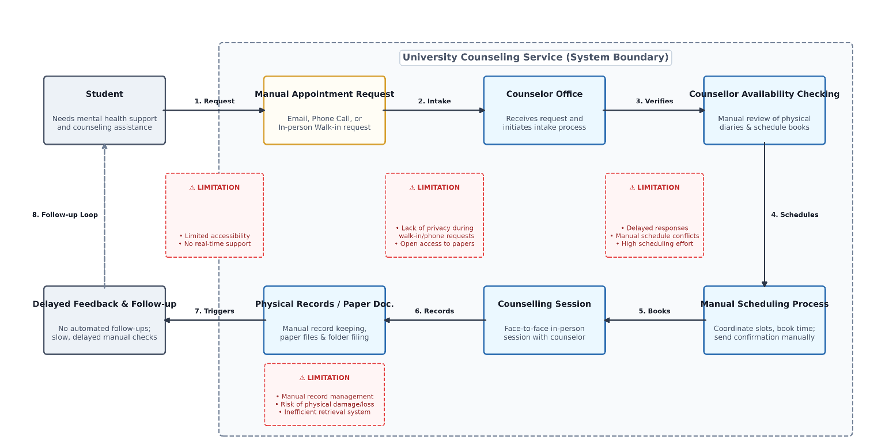
Figure 2.2: Existing System Architecture

2.3 Overview of Student Mental Health Challenges
The transition to university life is widely recognised as a period of heightened psychological vulnerability. Academic demands, unfamiliar social environments, financial pressures, and, for many students, distance from established support networks combine to increase the risk of stress, anxiety, and depressive symptoms. Traditional university counselling centres, while valuable, are often constrained by limited staff-to-student ratios, restricted operating hours, and the social stigma that can discourage students from making an initial appointment. These constraints have motivated growing interest in digital tools that can complement, rather than replace, professional counselling services by providing continuous, low-barrier engagement.

2.4 Related Technologies
Conversational agents used in mental health applications generally fall into two categories. Rule-based (or "retrieval"-style) chatbots rely on keyword matching or decision trees to select from a predefined bank of responses; they are inexpensive to build, fully predictable, and easy to audit for safety, but their responses can feel repetitive and they lack genuine natural-language understanding. In contrast, chatbots built on large language models can generate more contextually nuance responses but introduce additional considerations around response unpredictability, data privacy, and the need for careful safety guardrails, particularly when discussing self-harm or crisis-related content. Given these trade-offs, and the safety-critical nature of a student-facing wellbeing tool, this project adopts a deterministic, rule-based approach for its predictability and straightforward crisis-keyword escalation, while identifying migration to an LLM-based assistant as a direction for future work (Section 8.5).
Gamification, the application of game-design elements in non-game contexts, has been widely used to encourage sustained engagement with self-help and habit-forming applications. Short, low-stakes interactive activities such as bubble-popping simulations, breathing-paced animations, and simple puzzle games have been used in commercial wellbeing applications to provide an immediate outlet for stress or anxious energy. This project extends that concept substantially by implementing a library of more than thirty distinct relaxation mini games that are dynamically recommended according to the user's most recently logged mood value, an approach intended to match activity intensity and tone to the user's emotional state.
WebSocket-based libraries such as Socket.IO are widely used to implement real-time, bidirectional communication in web applications, enabling features such as live chat and presence-based matchmaking without the overhead of continuous HTTP polling. For video consultation, open-source solutions such as Jitsi Meet provide a browser-embeddable video-conferencing capability that can be integrated via a simple iframe without requiring a custom WebRTC signaling implementation, making it a pragmatic choice for a student project seeking to provide video counselling functionality without the engineering overhead of building peer-to-peer media negotiation from scratch.

2.5 Rule-Based versus AI/LLM-Based Chatbots in Mental Health Contexts
Conversational agents used in mental health applications generally fall into two categories. Rule-based (or "retrieval"-style) chatbots rely on keyword matching or decision trees to select from a predefined bank of responses; they are inexpensive to build, fully predictable, and easy to audit for safety, but their responses can feel repetitive and they lack genuine natural-language understanding. In contrast, chatbots built on large language models can generate more contextually nuanced responses but introduce additional considerations around response unpredictability, data privacy, and the need for careful safety guardrails, particularly when discussing self-harm or crisis-related content. Given these trade-offs, and the safety-critical nature of a student-facing wellbeing tool, this project adopts a deterministic, rule-based approach for its predictability and straightforward crisis-keyword escalation, while identifying migration to an LLM-based assistant as a direction for future work (Section 8.5).

2.6 Gamification and Mini-Games in Stress Management
Gamification, the application of game-design elements in non-game contexts, has been widely used to encourage sustained engagement with self-help and habit-forming applications. Short, low-stakes interactive activities such as bubble-popping simulations, breathing-paced animations, and simple puzzle games have been used in commercial wellbeing applications to provide an immediate outlet for stress or anxious energy. This project extends that concept substantially by implementing a library of more than thirty distinct relaxation mini games that are dynamically recommended according to the user's most recently logged mood value, an approach intended to match activity intensity and tone to the user's emotional state.

2.7 Real-Time Communication Technologies for Peer and Professional Support
WebSocket-based libraries such as Socket.IO are widely used to implement real-time, bidirectional communication in web applications, enabling features such as live chat and presence-based matchmaking without the overhead of continuous HTTP polling. For video consultation, open-source solutions such as Jitsi Meet provide a browser-embeddable video-conferencing capability that can be integrated via a simple iframe without requiring a custom WebRTC signaling implementation, making it a pragmatic choice for a student project seeking to provide video counselling functionality without the engineering overhead of building peer-to-peer media negotiation from scratch.

Table 2.8: Comparison of Existing Systems
Feature | Legacy Paper Logs | Commercial Mobile Apps | MindSpace Support System
Privacy / Stigma | Low (Visible Entry) | Medium (Profile Stored) | High (Animal Pseudonyms)
24/7 Availability | None (Office Hours) | Continuous (Paid Tier) | Continuous (Free Access)
Bilingual Support | Direct (If Available) | Restricted (English Only) | Automated (Sinhala/English)
Conflict Checks | Manual Verification | Centralized Server | DB Overlap Checking
Coping Tool Sync | None | Generalized Static Lists | Dynamic(Logs Correlated)

2.9 Research Gap Addressed by This Project
While individual components mood trackers, psychoeducational content, chatbots, and tele-counselling booking systems are each well represented in the existing literature and commercial marketplace, relatively few freely available, academically documented projects integrate all of these components, together with anonymous peer support and administrative oversight tooling, into a single unified platform purpose-built for a university student population. MindSpace addresses this gap by combining mood analytics, gamified self-help, rule-based AI assistance, peer support, and a full counsellor booking and payment-settlement workflow within one coherent, role-based system, as detailed in the following chapters.

2.10 Chapter Summary
This chapter reviewed the literature and technologies relevant to the development of the MindSpace – Student Mental Health Support System. It examined the mental health challenges commonly experienced by university students and discussed the limitations of existing counselling services and digital mental health solutions. The chapter also explored related technologies, including rule-based chatbots, gamification techniques, real-time communication technologies, and video conferencing tools, highlighting their roles in supporting student wellbeing.
Furthermore, the chapter compared existing systems with the proposed MindSpace platform and identified the research gap addressed by this project. The review demonstrated the need for an integrated, role-based solution that combines mood tracking, AI-assisted guidance, anonymous peer support, counsellor booking, and administrative management within a single platform. Overall, the findings from the literature review provide the theoretical and technological foundation for the system design and implementation discussed in the following chapter.
.

Chapter 3: Methodology

3.1 Research Approach
The development of MindSpace is grounded in an empirical, user-centric research approach. Prior to writing code, a comprehensive analysis of legacy process parameters was conducted to understand operational failures regarding stigma and delayed booking. This quantitative tracking informed the design of a decoupled client-server structure, ensuring that metadata boundaries and socket channels directly correspond to verified academic and usability requirements.
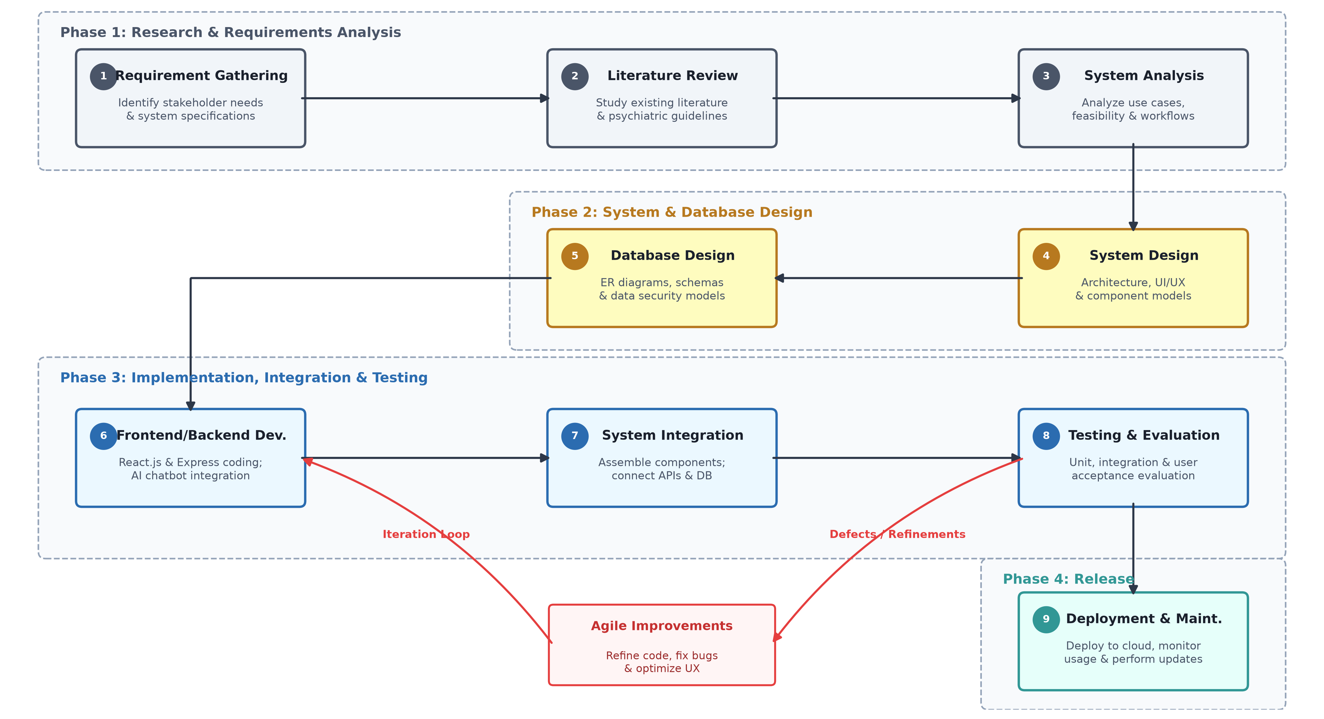
Figure 3.1: System Development Process

3.2 System Development Methodology
The system architecture was engineered using an agile prototyping methodology, allowing for continuous integration of modules based on interface evaluations. The development was broken down into functional iterations: building the Mongoose collection layers, establishing Socket.IO bidirectional ports, and assembling responsive React components. Regular code reviews ensured token authentications and database constraints matched standard development rules.

3.3 Requirement Gathering
Requirements for the MindSpace system were derived from an analysis of common pain points reported in the student mental health literature, combined with an examination of feature sets offered by comparable commercial platforms such as tele-counselling booking services and mood-tracking applications. The resulting requirements were validated against the implemented codebase to ensure that every functional requirement corresponds to a feature that is actually present in the delivered system.
The system operates with three primary user roles:
- Student Users: Access wellness tools, track moods, play relaxation games, chat with AI Aura, and book sessions with counselors.
- Counselor Users: Set availability, review student requests, conduct live chats, write clinical remarks, and track payout earnings.
- Administrators: Manage user registrations, review counselor applications (KYC), monitor activity logs, and oversee announcements and system health.

3.4 Tools and Technologies
The system is built on a multi-tiered development architecture selected to maintain speed, cross-platform stability, and document model changes. The choice of technologies balances backend validation control with rich interactive components on the client side.

Table 3.5: Software and Hardware Requirements
Layer / Concern | Technology Specification | Operational Purpose
Development Machine | Core i7 CPU, 16GB RAM, Windows 11 | Compilation and Local Cluster Emulation
Integrated Env. | Visual Studio Code v1.90+ | Codebase Editing and Script Tasks Run
API Testing Engine | Postman Client UI | Route Payload and Status Verification
Runtime Engine | Node.js Runtime Platform v24 LTS | Server Bootstrap and Port Asynchronous I/O
Web Server Framework | ExpressJS Routing Pipeline v5.2 | Request-Response Pipeline Control
Client Bundler Engine | Vite Bundler Assembly Framework v8 | Component Packaging and Live Hot Reloading

3.6 Chapter Summary
This chapter described the methodology adopted for the design and development of the MindSpace – Student Mental Health Support System. It explained the research approach and the use of an agile prototyping methodology, which enabled the system to be developed through iterative improvements based on user and technical requirements. The chapter also outlined the requirement gathering process and identified the key user roles—students, counsellors, and administrators—along with their respective responsibilities within the system.
Furthermore, the chapter presented the software and hardware technologies used during development, including the MERN stack, Visual Studio Code, Postman, Node.js, Express.js, and Vite. These technologies provided a reliable and scalable foundation for implementing the system's features. Overall, this chapter establishes the methodological framework that guided the successful development of MindSpace and prepares the reader for the system analysis and design presented in the next chapter.

Chapter 4: System Analysis and Requirements

4.1 System Architecture
The system architecture follows a decoupled, client-server design pattern. The client tier, assembled via React single-page components, coordinates UI states locally, while the server tier manages operational loops through centralized Express controllers. Security constraints are evaluated at the network perimeter via custom token check layers.
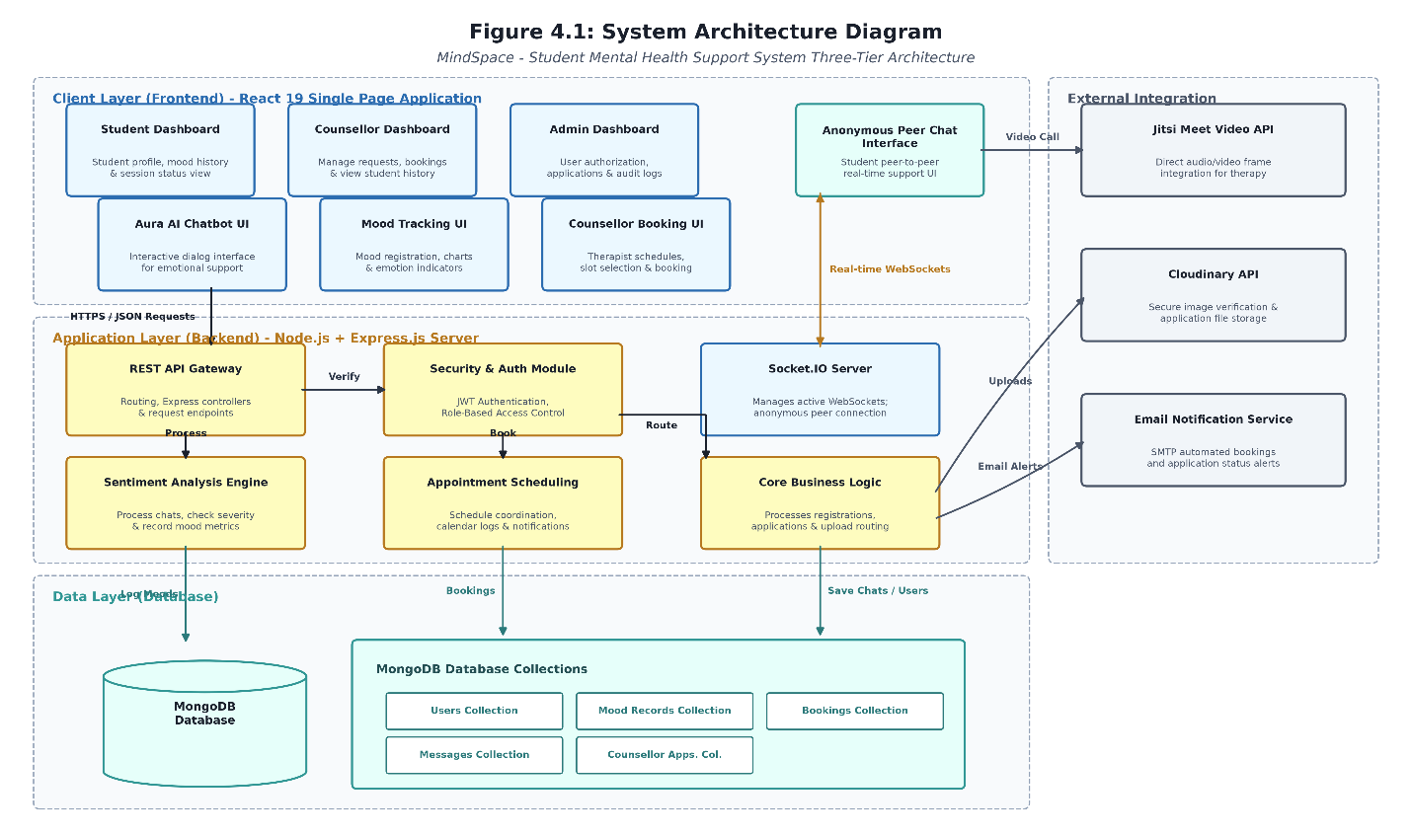

Figure 4.1: System Architecture Diagram

4.2 Use Case Diagram
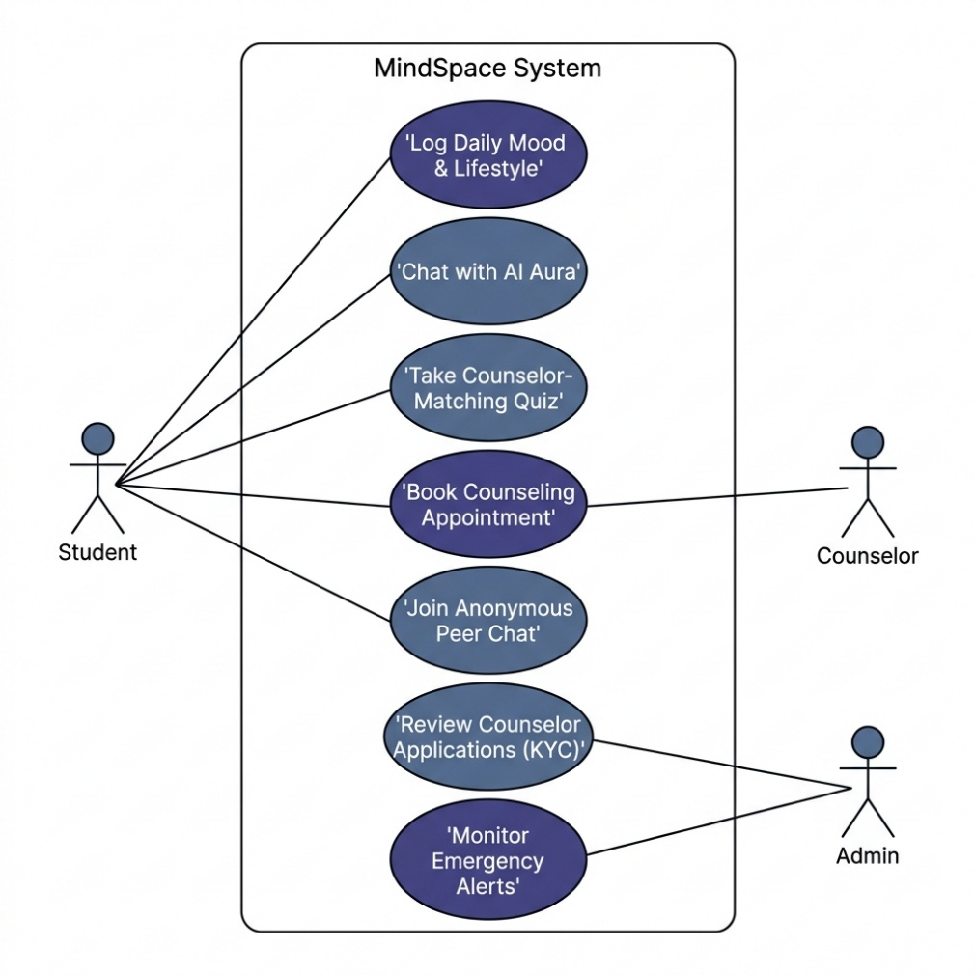
The case model defines structural relationships between actors and system modules.
Figure 4.2: Use Case Diagram

4.3 Client / End-User Requirements

Web Browser: Google Chrome, Firefox, Safari, Edge (latest versions).
Connection: Stable internet connection (3G, 4G, 5G or Wi-Fi).

4.4 System Design

4.4.1 System Modules

- Authentication Module
Verifies logins via JWT tokens, hashes passwords using Bcrypt, and handles 30-minute lockout protection after 5 failed attempts.
- Mood Tracking Module
Logs mood levels (1-5), processes journal text sentiment polarities, and updates consecutive-day streaks.
- AI Chatbot (Aura) Module
Operates client-side keyword-driven dialogs, translating instantly between English and Sinhala, and surfaces helpline numbers for crisis terms.
- Counsellor Matching & Booking Module
Matching wizard computing ranked matches, calendar time slot configurations, and database overlap checks.
- Anonymous Peer Chat Module
matchmaking queue that joins students into private WebSocket rooms, assigning random animal aliases to preserve privacy.
- Wellness Resources & Games Module
Curated wellness articles grid, animated breathing coach balloon, and a local library of 30+ Web Audio/Canvas games (e.g. bubble wrap popper).
- Notification Module
Triggers live notifications for booking state modifications, payout confirmations, and new counselor reviews.
- Multi Language Support Module
Bilingual translation dictionary swapping state variables in page headers and chatbot fields without refreshing.
- KYC Verification Module
Upload middleware sending advisor NIC cards and professional certifications to Cloud nary CDN folder.
- Admin Management Module
Analytics dashboard displays database metrics, user profiles, setup announcements, and emergency alerts warnings.

4.5 Database Design
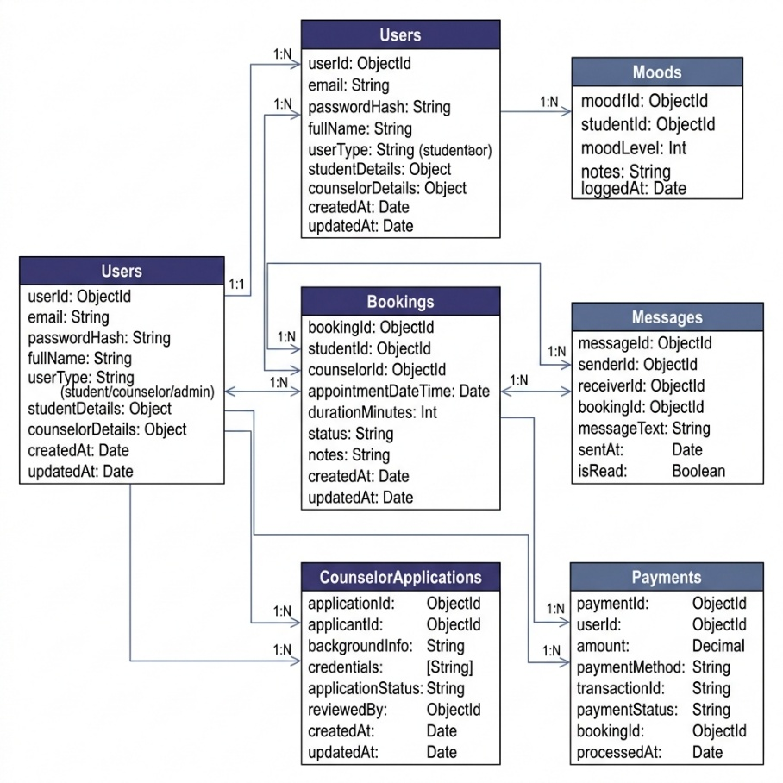
The Entity-Relationship (ER) model shows how schemas relate to each other. Users reference bookings and logs. Message entries map rooms string attributes to bypass complex chat logs dependencies.

Figure 4.3: Entity Relationship Diagram (ERD)
The attributes Structure of the models is structured to isolate operational payloads from system configuration variables. Class maps attributes (id, email, passwordHash, role, streakCount) and schema validators.

Table 4.6: Functional Requirements

Table 1 summarizes the core functional requirements (FR) implemented in the MindSpace system.
ID | Requirement
FR-01 | Allow user registration and login, returning JSON Web Token (JWT) session cookies.
FR-02 | Allow students to log daily mood alongside sleep hours, water intake, screen time, exercise, weather, color, activities, and notes.
FR-03 | Examine mood logs notes utilizing a rule-based sentiment engine, returning positive/neutral/negative ratings and wellness hints.
FR-04 | Calculate daily logging streaks and award wellness badges (e.g. 3-day Explorer, Hydration Hero, Zen Master).
FR-05 | Aggregate logs history displaying weekly trends, sleep-mood correlations, and heatmap grids.
FR-06 | Recommend 5 interactive games (such as Sudoku, Flappy Bird, Worry-balloon release) matching the user mood value.
FR-07 | Empathetic chatbot Aura translating responses between Sinhala and English, detecting crisis keywords to show helplines numbers.
FR-08 | Counsellor discovery matching questionnaire and calendar appointment scheduling conflict check pipeline.
FR-09 | Peer anonymous WebSockets chat room assigning random animal aliases to user sockets.
FR-10 | Administrative console monitoring analytics charts, verifying counselor documents uploads (KYC), and payment logs.

Table 4.7: Non-Functional Requirements
Table 2 summarizes the non-functional requirements (NFR) that shaped key architectural decisions.
ID | Category | Requirement
NFR-01 | Security | Hash user passwords using Bcrypt. Enforce JWT tokens authorization on APIs routes.
NFR-02 | Usability | Provide responsive web layout. Support English and Sinhala languages translation controls.
NFR-03 | Performance | Timeout slow third-party calls (Lichess, OpenTrivia) after 2 seconds to load local fallbacks.
NFR-04 | Availability | Clean up match queues on sockets disconnect. Gracefully reconnect live chat connections.
NFR-05 | Scalability | Document database structure (MongoDB Atlas) to scale horizontally.

4.8 Class Diagram
Represents properties structure of the models. Class maps attributes (id, email, passwordHash, role, streakCount) and schemas validators.

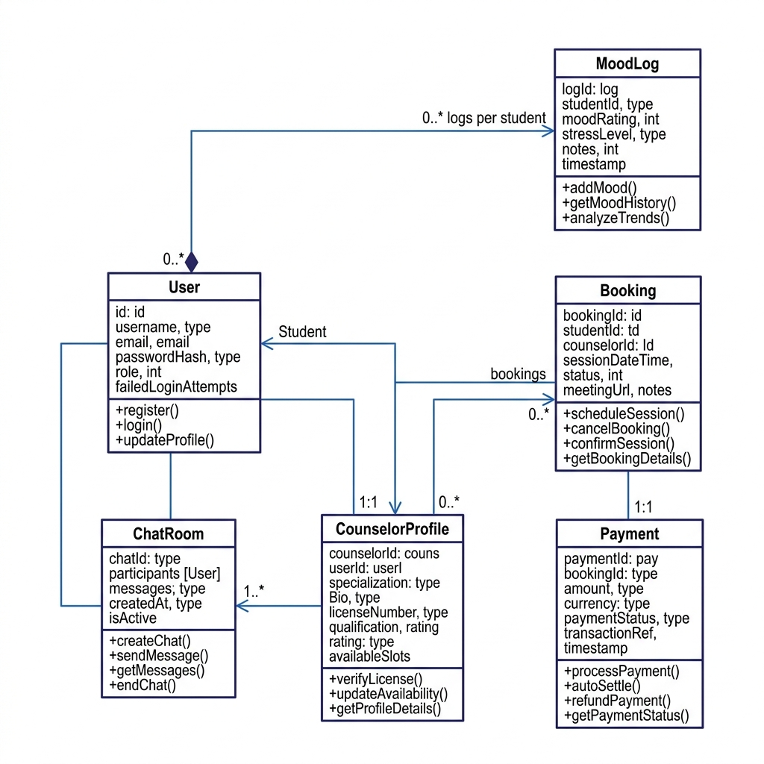
Figure 4.8: Class Diagram

4.9 User Interface Design
The user interface design emphasizes high scannability, dark-mode accessibility, and clear role separation across modules. The forms map validation feedback fields directly below inputs, keeping visual boundaries consistent.
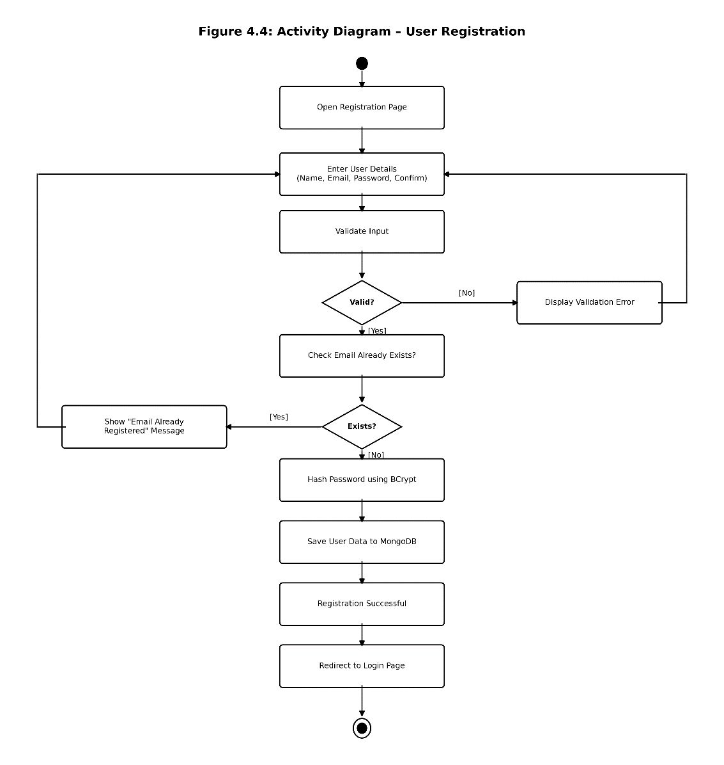

Figure 4.9: Activity Diagram - User Registration

Table 4.10: Database Tables Description

Collection Name | Reference Key Mappings | Core Monitored Field Attributes
Users | Primary _id: ObjectId | email,passwordHash,role,status, streakCount
Moods | Ref: user: ObjectId | moodValue,note,sleepHours, sentimentScore
Bookings | Ref: student, counsellor | appointmentDateTime,timeSlot,status, paymentStatus
Messages | Ref: sender, receiver | text, room, senderName, sentAt, isRead

4.11 Database Schema
Database Collections structures (Users, Moods, Bookings, Messages, Counselor Applications, Payments, Feedback). Details are provided in Appendix A.

Table 4.12: Technology Stack

Layer / Concern | Technology
Frontend | React 19.2 SPA + Vite 8 bundler engine
Backend APIs | Node.js (v24) + Express.js 5.2 MVC routing framework
Database | MongoDB Atlas cloud clusters + Mongoose ORM schemas validation
Real-time Chat | Socket.io 4.8 duplex channels on port 5000
Media & CDN | Cloudinary image hosting API + Jitsi Meet browser iframes

4.13 Frontend Component and Routing Design
The frontend layout is mapped using modular pages (Dashboard, MoodTracker, AIChatbot, Booking, Resources) connected by React Router v7. Route components are wrapped with a dynamic ProtectedRoute check that inspects localStorage JWT keys.

Table 4.14: API Design
Table 4 lists representative API endpoints exposed by the Node API server.
Method & Path | Purpose | Access Level
POST /api/auth/login | User sign-in credentials validation returning JWT keys | Public
POST /api/mood | Submit a mood log with activities, sleep, and weather | Student
GET /api/mood/analytics | Compute mood averages, weekly trend series, and heatmaps | Student
POST /api/bookings | Register counseling appointment request slot | Student
PUT /api/bookings/:id | Approve or reject booking slots (with conflict validator) | Counsellor/Admin

4.15 Security Design
Encrypted credentials are structured via Bcrypt hashes with 10 salt rounds. Protected route calls verify JSON Web Token parameters inside authorization headers, and administrative access check’s role states

4.16 Chapter Summary
This chapter presented the analysis and design of the MindSpace – Student Mental Health Support System. It described the overall system architecture, use case model, database design, and functional and non-functional requirements that guided the development process. The chapter also identified the hardware and software requirements needed by end users and explained how the proposed system addresses the identified requirements through a modular architecture.
Furthermore, the chapter detailed the major system modules, including authentication, mood tracking, AI chatbot, counsellor booking, anonymous peer chat, wellness resources, notifications, multilingual support, KYC verification, and administrative management. It also discussed the database schema, user interface design, frontend routing, API design, and security mechanisms such as JWT authentication and password hashing. Overall, this chapter provides a comprehensive blueprint of the MindSpace system and serves as the foundation for the implementation and testing presented in the following chapter.

Chapter 5: Database Schema Design (MongoDB)

5.1 Overview of the Database Architecture

The MindSpace system utilizes MongoDB as its primary database backend, managed via the Mongoose ODM (Object Document Mapper) in Node.js. A NoSQL, document-oriented database was chosen to handle semi-structured data like real-time chat transcripts, dynamic self-reflection journals, and personalized wellness recommendations.

Instead of traditional tables and rows, data is stored in flexible JSON-like documents. Relationships between collections are maintained using MongoDB Object IDs (ObjectId) and Mongoose references (ref), which act as soft foreign keys to ensure data integrity while enabling rapid queries.

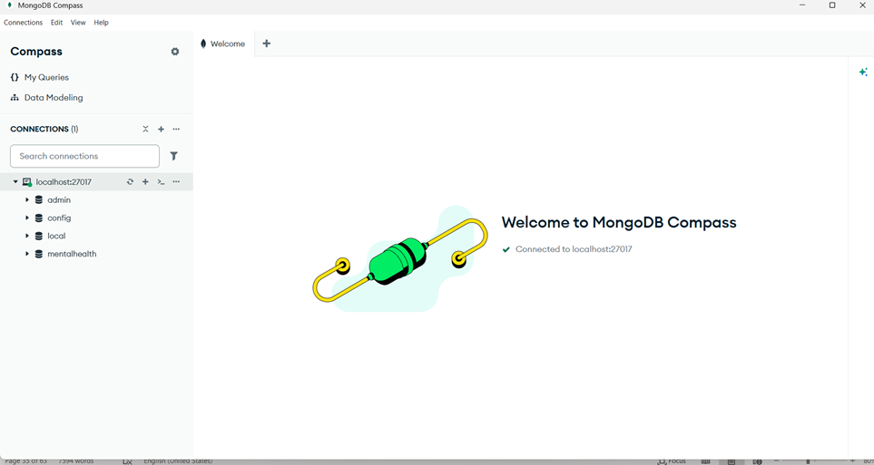

5.2 Key Collections and Document Schemas

5.2.1. The users Collection

The user’s collection stores authentication credentials, profile metadata, and system roles. The scheme supports role-based classification (student, counsellor, admin) to restrict API endpoints. For counselor profiles, it embeds a sub-document containing professional banking details, and for students, it stores custom recommendations curated by advisors.

Key Fields:

name (String): The full name of the user.

email (String): Unique identifier used for authentication.

password (String): Stored as a secure salted hash (bcrypt).

role (String): Categorization tag (student, counsellor, admin).

status (String): Account state control (active or deactivated).

custom Recommendation (Object): Embedded fields containing suggested game and activity tip strings.

bankDetails (Object): Embedded fields storing bank name, branch name, account number, and holder name (counselor-specific).

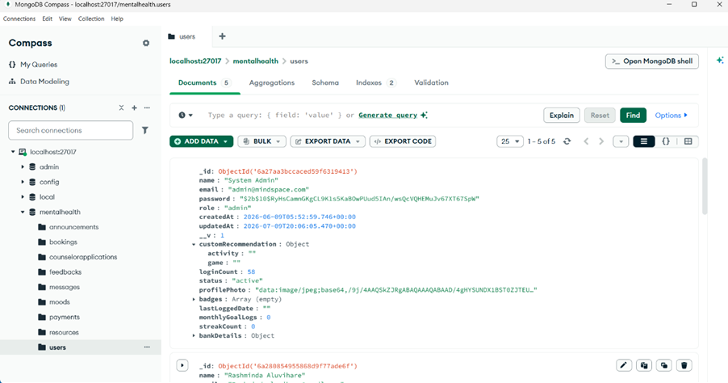

5.2.2 The moods Collection

The moods collection archives daily mental wellness logs recorded by students. It links each log entry back to a specific user and records physical metrics along with qualitative thoughts.

Key Fields:

user (ObjectId): Reference linking back to the user’s collection.

moodValue (Number): Emotional scale integer (1 to 5).

note (String): Qualitative reflection diary text.

sleepHours (Number): Total sleep duration.

waterIntake (Number): Hydration levels logged in milliliters.

screenTime (Number): Digital device screen usage logged in hours.

isExamPeriod (Boolean): Academic schedule stress flag.

sentimentScore (Number): Computed value indicating positive or negative sentiment.

recommendations (Array): Dynamically compiled tips generated by the rules engine.
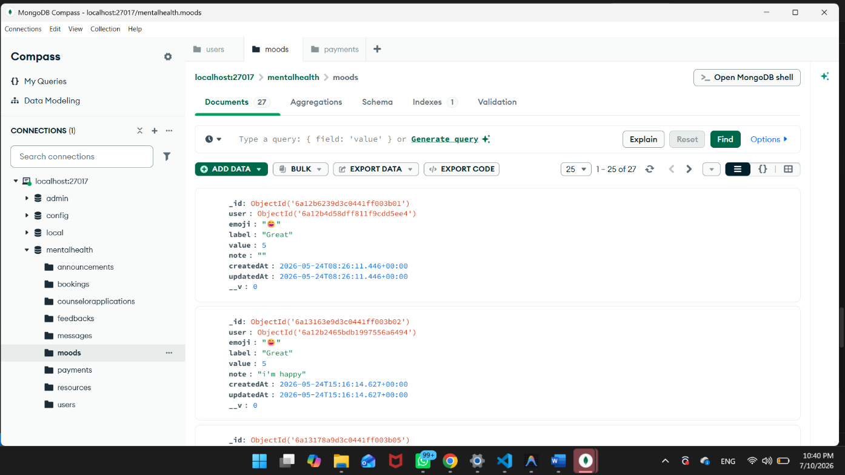

5.2.3 The bookings Collection

This collection tracks student scheduling appointments requested with verified counselors. It handles reservation states and integrates billing markers.

Key Fields:

student (ObjectId): Reference to the student user requesting the session.

counsellor (ObjectId): Reference to the assigned counselor user.

counsellorName (String): Denormalized counselor name for rapid UI displaying.

date (String): Target scheduling date

timeSlot (String): The approved hour interval.

note (String): Brief explanation of student needs.

status (String): Lifecycle state (pending, approved, rejected).

paymentStatus (String): Billing validation indicator (unpaid, paid).

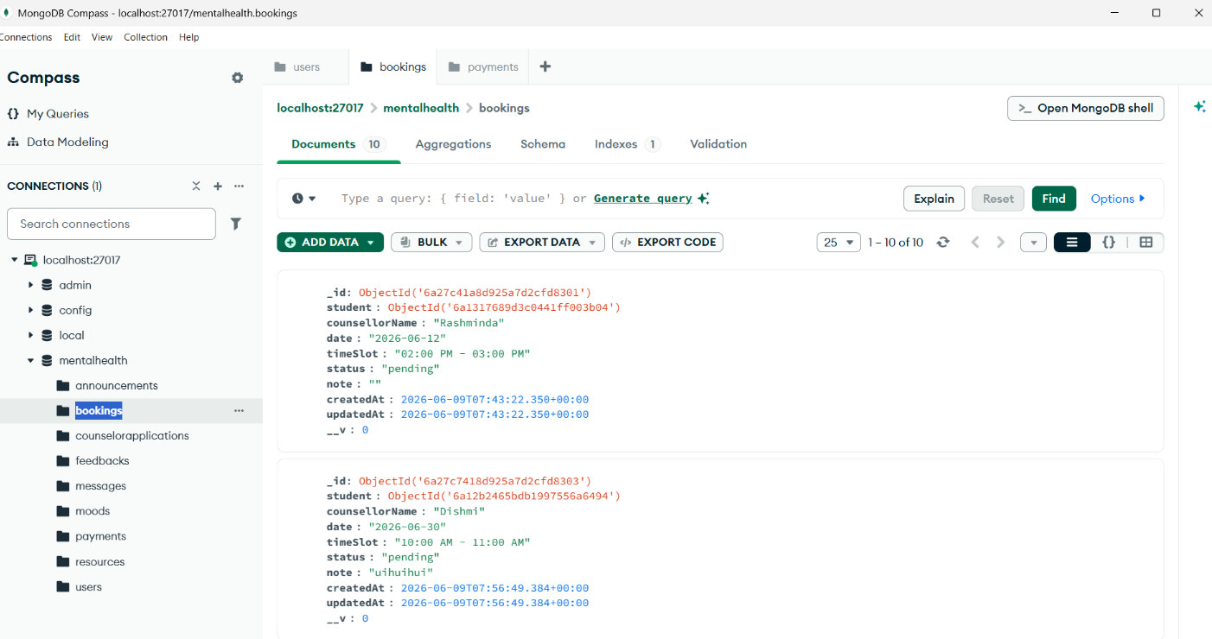
rejectionReason (String): Optional note provided by the counselor upon declining.

5.2.4 The messages Collection

The messages collection persists in real-time communications taking place within counseling sessions and anonymous support lines.

Key Fields:

sender (ObjectId): Reference to the sender.

receiver (ObjectId): Reference to the recipient.

senderName (String): Nickname or screen alias.

text (String): The actual message payload.

room (String): Unique socket identifier mapping the conversation room.

createdAt (Date): Auto-generated timestamp.

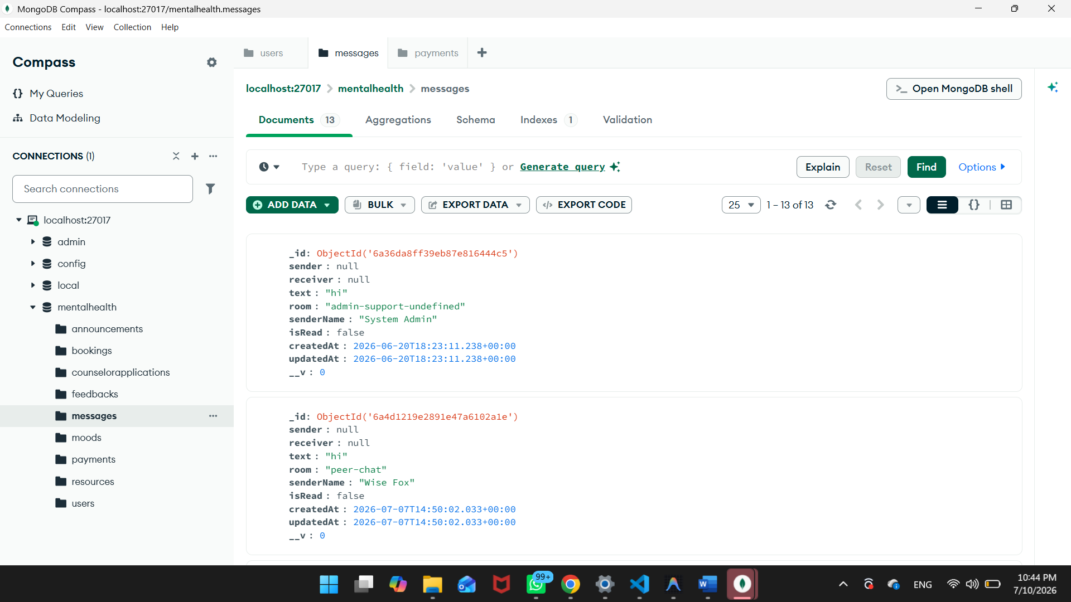

5.2.5 The counselor applications Collection

This collection acts as a staging queue for candidate profiles applying for a professional counseling role, pending review by administrators.

Key Fields:

user (ObjectId): Reference to the user applying.

fullName (String): Professional name of the applicant.

nic (String): National Identity Card number.

qualifications (Array): Academic credentials.

licenseNumber (String): Medical or counseling registration details.

counsellorIdFront (String): Base64 encoded or hosted URL of the ID front.

counsellorIdBack (String): Base64 encoded or hosted URL of the ID back.

status (String): Verification status (pending, approved, rejected).

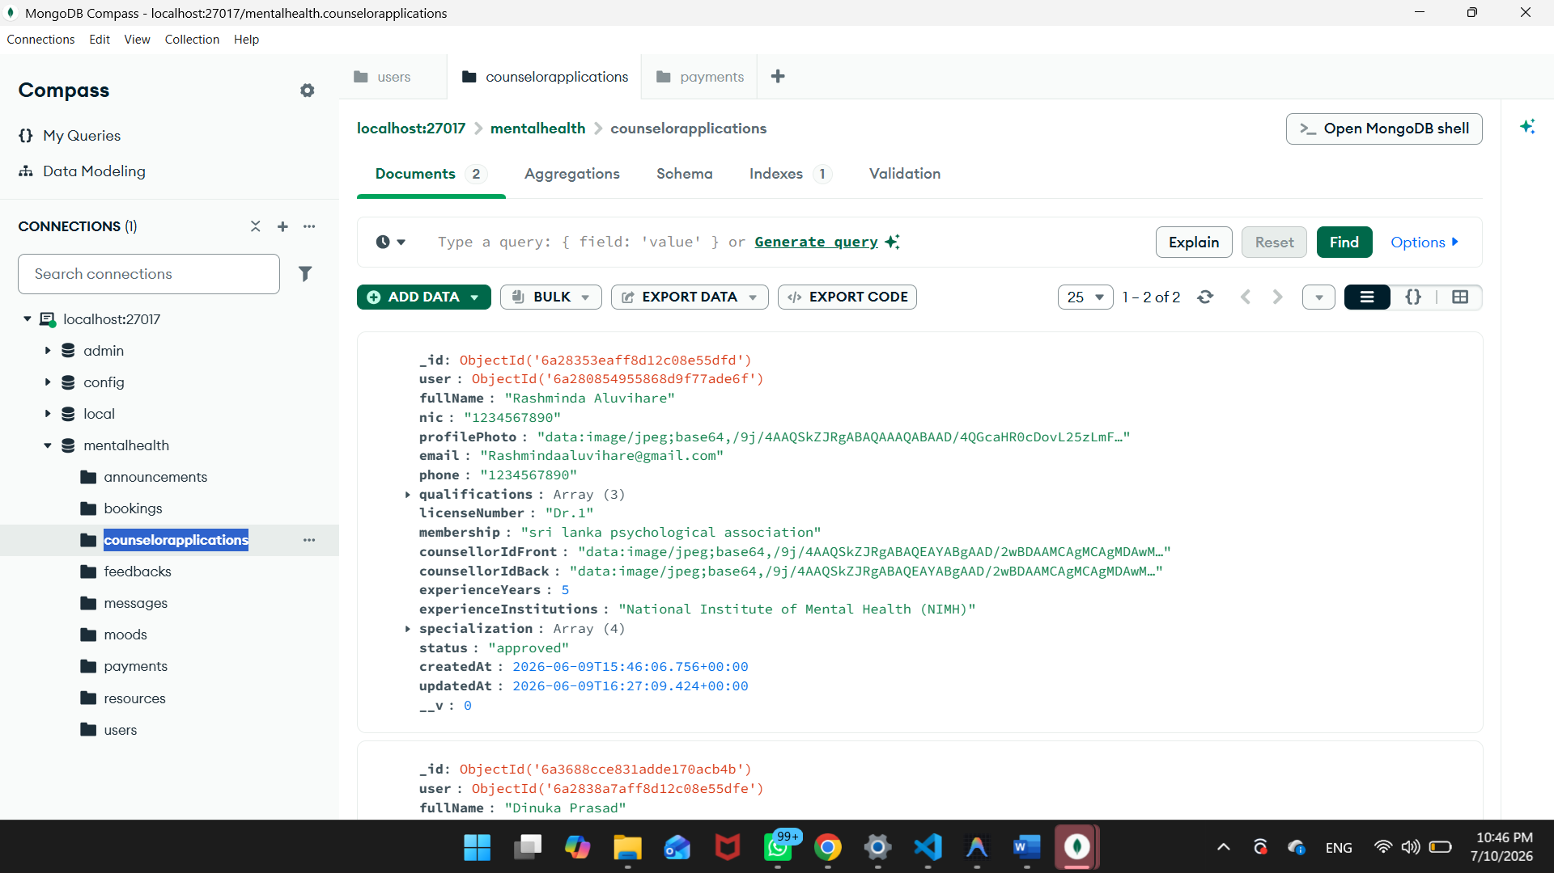

5.2.6 The payments Collection

This ledger manages counselor payouts, recording completed appointments, earnings, and administrative pay-out states.

Key Fields:

counsellor (ObjectId): Reference to the earner.

student (ObjectId): Reference to the client student.

booking (ObjectId): Reference to the completed session.

amount (Number): Calculated payout fee.

status (String): Settlement state (pending or paid).

paidAt (Date): Timestamp when the admin completed the transfer.

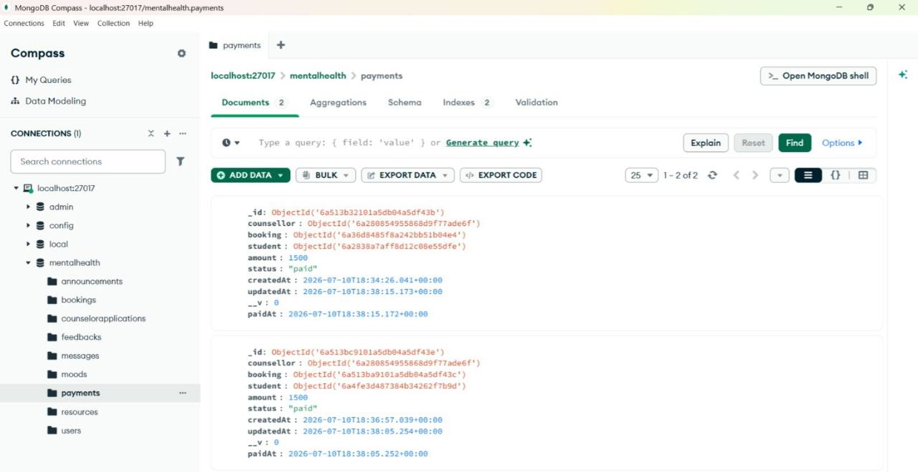

Chapter 6: System Implementation

6.1 Development Environment
The project was compiled on VS Code, Node runtime v24, and local MongoDB server nodes. API client testing tasks were run using Postman to verify routes responses.

6.2 Backend Implementation

6.2.1 Server Bootstrap and Real-Time Layer
- Express server bootstraps from server.js. WebSocket layer handles matchmaking queues: checks if a student is waiting, groups users into room names, and triggers message transfers.

6.2.2 Authentication and Authorization
- routes/auth.js handles registration. Express middleware checks token validity, and rejects users whose status flag equals deactivated.

6.2.3 Mood Logging, Sentiment Analysis, and Gamified Streaks
- routes/mood.js processes inputs: checks note tokens string polarity, triggers alerts on low sleep hours, computes streaks, and saves badges arrays.

6.2.4 Mood Analytics Engine
- Aggregates records: averages log scores, maps triggers, compiles trends formatting arrays for React chart elements, and processes linear predictions.

6.2.5 Mood-Based Recommendation Engine and External API Integration
- Recommends resources based on logs. Lichess, OpenTrivia, or ZenQuotes API fetch tasks are run with a 2-second timeout, loading fallback arrays on error.

6.2.6 Booking, Payment, and Counsellor Payout Workflow
- routes/bookings.js manages slot allocation. Upon bookings approvals, a payment model is created with a flat LKR 1,500 counselor payout fee, which is settled inside the admin payout module

6.3 System Implementation

6.3.1 Programming Languages Used
JavaScript (ES6+): Utilized in backend routes controllers, Socket.io, and React client pages.
HTML5: Represents structural layouts of React views.
CSS3: Dynamic variables, dark mode styling colors, and visual balloon animation templates.

6.3.2 Tools and Technologies
React 19 SPA + Vite 8 bundler.
Node.js (v24) + Express server.
MongoDB Atlas database cloud.
Socket.io real-time layer.

6.3.3 Key Features
Bilingual AI Aura chatbot (English/Sinhala).
Visual box breathing Visualizer + Programmatic Audio Board.
Lockout security, password hashing, and KYC document uploads pipeline.

6.4 Development Environment
The project was compiled on VS Code, Node runtime v24, and local MongoDB server nodes. API client testing tasks were run using Postman to verify routes responses.

6.5 Backend Implementation

6.5.1 Server Bootstrap and Real-Time Layer
- Express server bootstraps from server.js. WebSockets layer handles matchmaking queues: checks if a student is waiting, groups users into room names, and triggers message transfers.

6.5.2 Authentication and Authorization
- routes/auth.js handles registration. Express middleware checks token validity, and rejects users whose status flag equals deactivated.

6.5.3 Mood Logging, Sentiment Analysis, and Gamified Streaks
- routes/mood.js processes inputs: checks note tokens string polarity, triggers alerts on low sleep hours, computes streaks, and saves badges arrays.

6.5.4 Mood Analytics Engine
- Aggregates records: averages log scores, maps triggers, compiles trends formatting arrays for React chart elements, and processes linear predictions.

6.5.5 Mood-Based Recommendation Engine and External API Integration
- Recommends resources based on logs. Lichess, OpenTrivia, or ZenQuotes API fetch tasks are run with a 2-second timeout, loading fallback arrays on error.

6.5.6 Booking, Payment, and Counsellor Payout Workflow
- routes/bookings.js manages slot allocation. Upon bookings approvals, a payment model is created with a flat LKR 1,500 counselor payout fee, which is settled inside the admin payout module

6.6 System Implementation

6.6.1 Programming Languages Used
JavaScript (ES6+): Utilized in backend routes controllers, Socket.io, and React client pages.
HTML5: Represents structural layouts of React views.
CSS3: Dynamic variables, dark mode styling colors, and visual balloon animation templates.

6.6.2 Tools and Technologies
React 19 SPA + Vite 8 bundler.
Node.js (v24) + Express server.
MongoDB Atlas database cloud.
Socket.io real-time layer.

6.6.3 Key Features
Bilingual AI Aura chatbot (English/Sinhala).
Visual box breathing Visualizer + Programmatic Audio Board.
Lockout security, password hashing, and KYC document uploads pipeline.

6.7 Code Structure
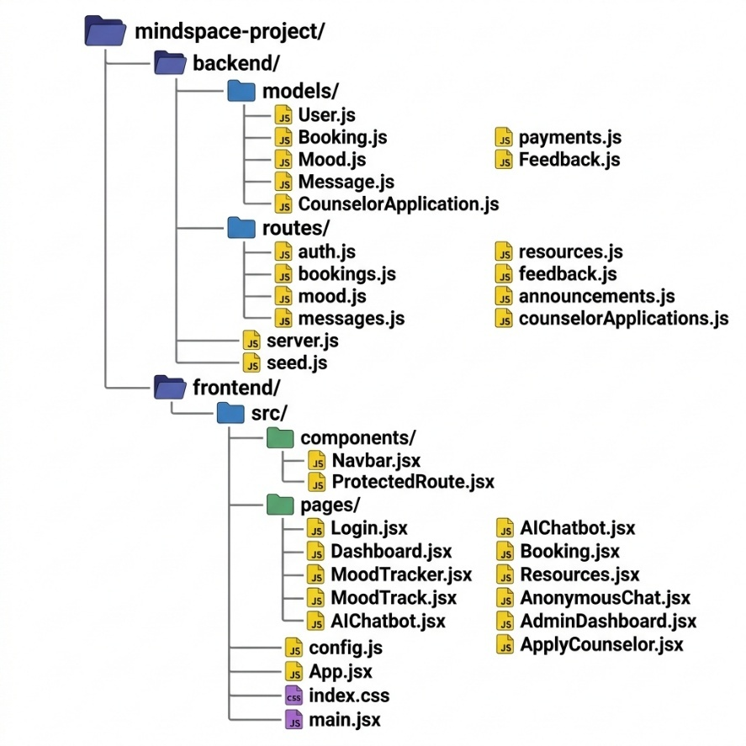

6.8 Frontend Implementation

6.8.1 Login & Registration
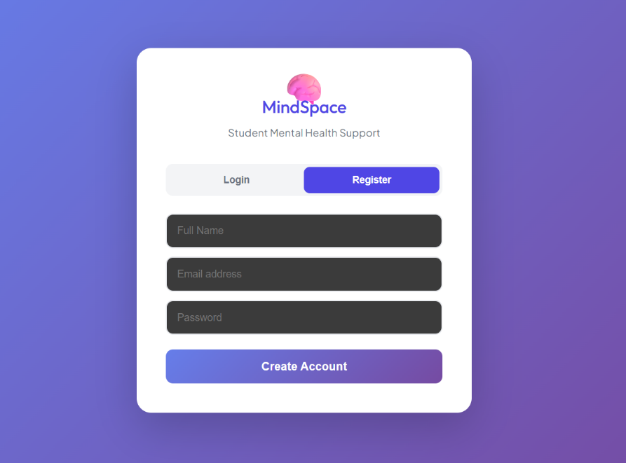

6.8.2 User Profiles

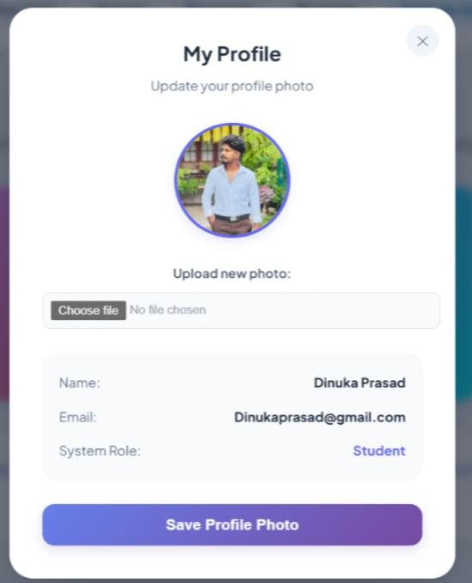
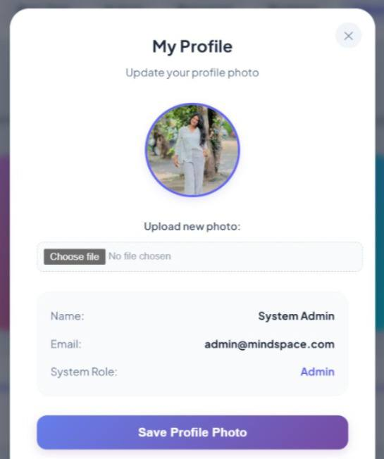
Admin Student

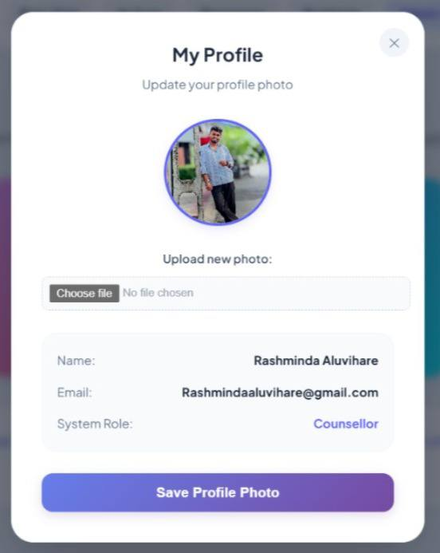
Counselor

6.8.3 Authentication and Dashboard
Login.jsx handles credentials from submission. The dashboard displays navigation cards, recommendations, and quotes banners.
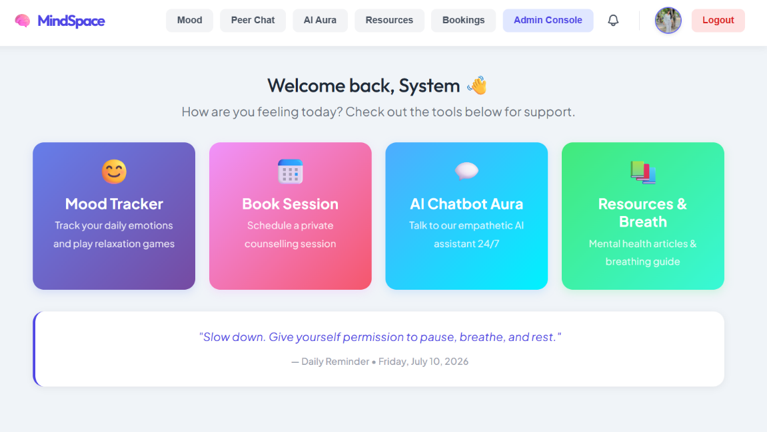

6.8.4 Mood Tracker Module
MoodTracker.jsx renders mood selectors, emoticons log grids, and the bubble pop canvas game. WebAudio API synthesizes sound feedbacks.

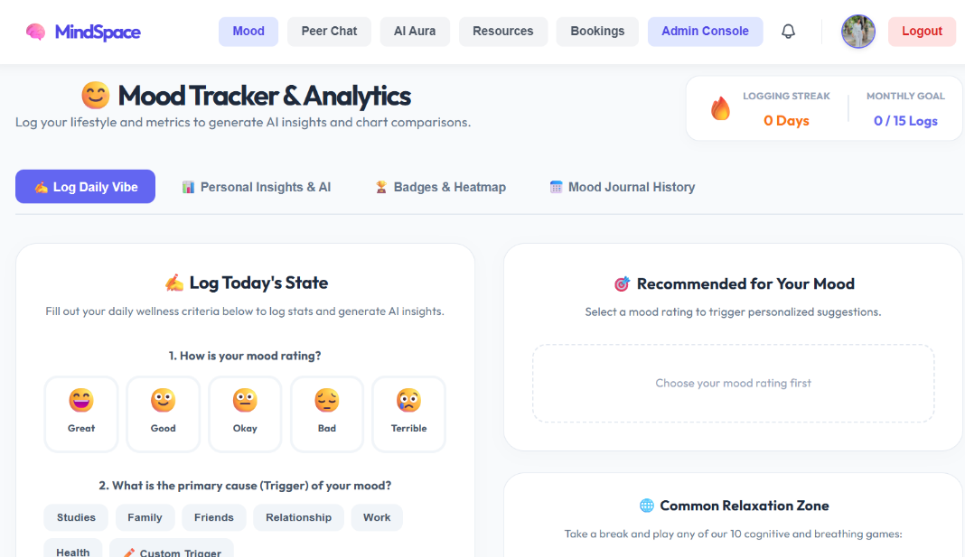

6.8.5 AI Chatbot ("Aura")
AIChatbot.jsx operates keyword checks. Evaluates Sinhala characters, maps response banks, and displays emergency helpline numbers for self-harm keywords.
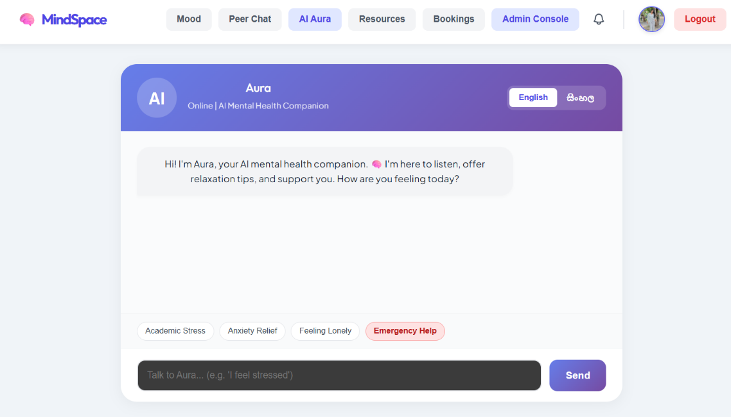

6.8.6 Booking Module
Booking.jsx operates counselor matching steps. Shortlists matches based on biography keyword matches, sets time slots, and launches Jitsi video iframe calls.
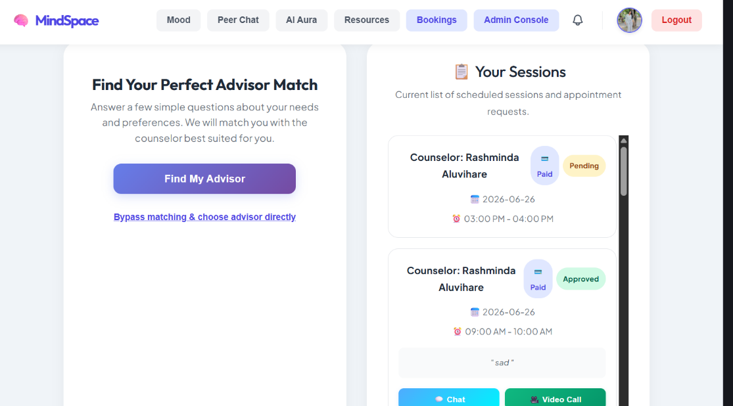

6.8.7 Resources and Guided Breathing Coach
Resources.jsx runs an animated box breathing coach visualizer (showing inhale, hold, exhale phases) with audio synthesis loops.

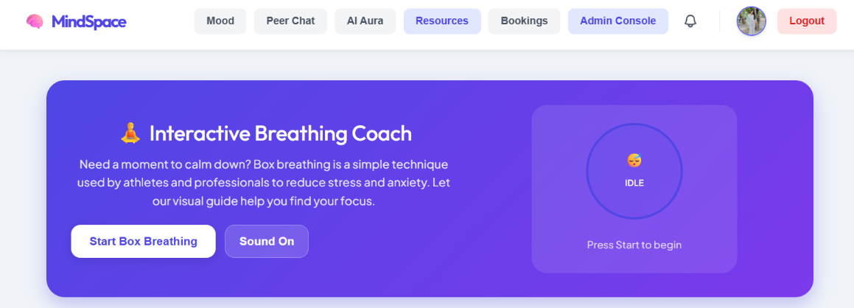

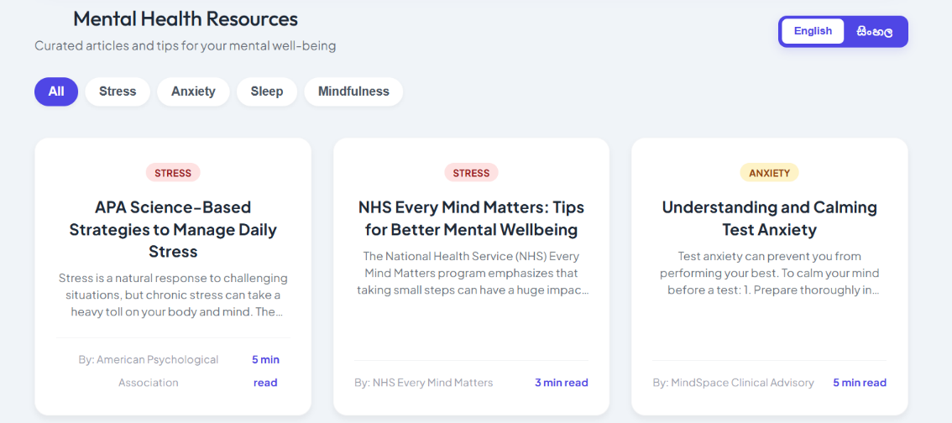

6.8.7 Anonymous Peer Chat and Admin Support Chat
Connects students anonymously, assigning random animal names as user aliases, and integrates helper channels for direct admin advice.
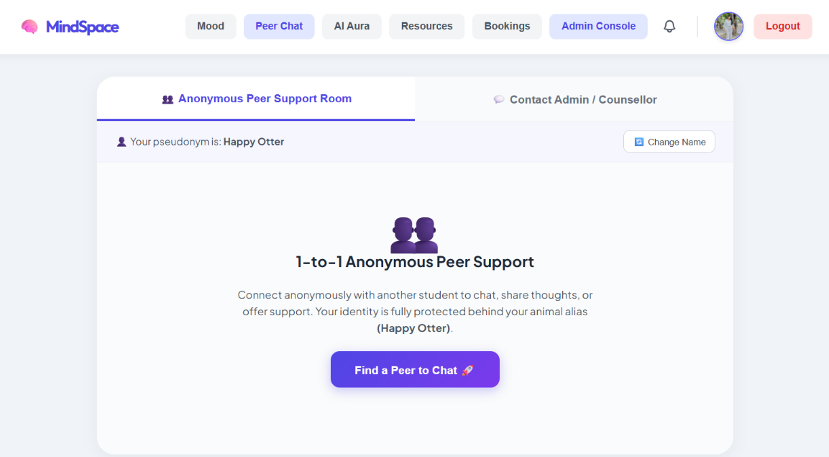

6.8.8 Counsellor Application Workflow
Counsellors submit credentials, professional licenses, and NIC card images. File upload flows send files to Cloudinary.

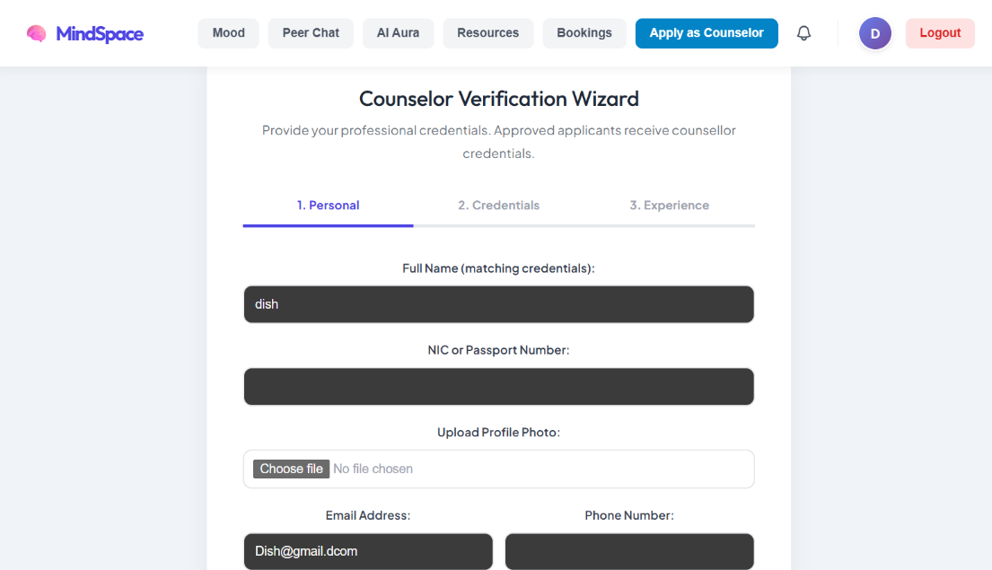

6.8.9 Administrative Dashboard
Renders analytical graphs, lists user profiles, handles application approvals, and displays counselor payouts tables.
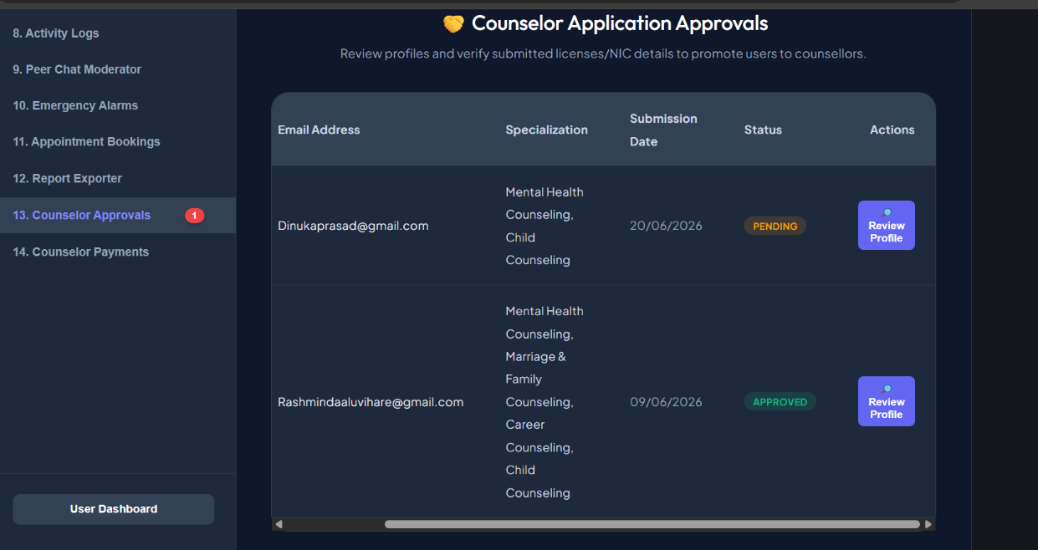
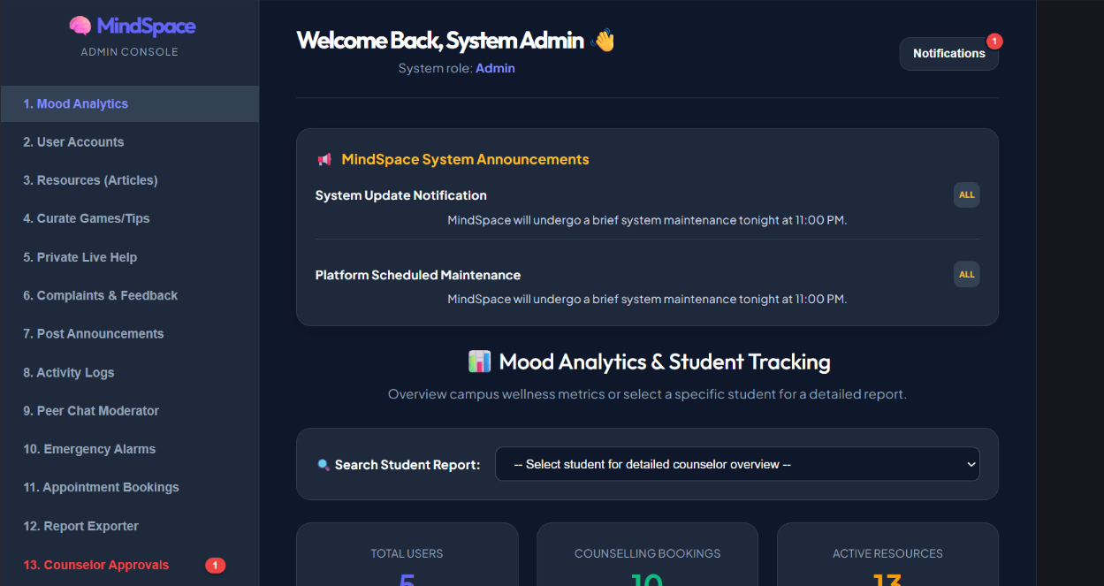
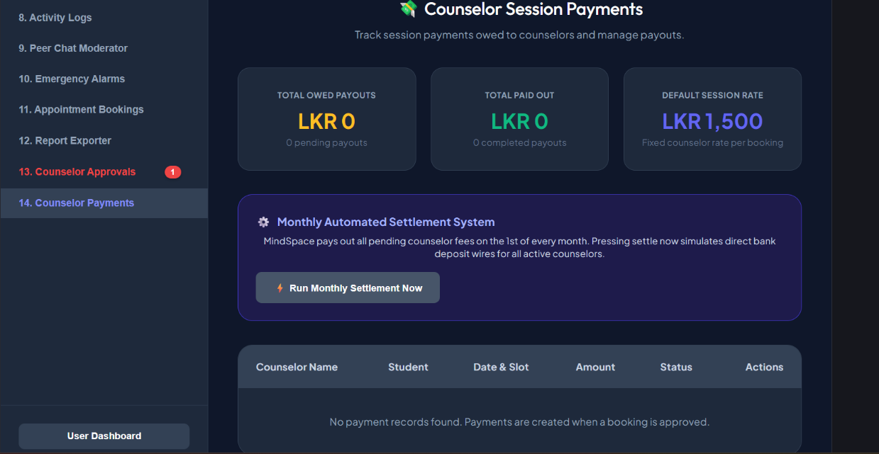

Table 6.8.9: Administrative Dashboard Modules

Module | Description
User & Moderation Management | Deactivate/activate accounts, audit profiles, monitor logs.
KYC Review Pipeline | Review NICs and certifications from Cloudinary, approve counselor upgrades.
Payment Settlement Console | Run monthly auto-settlement, mark pending payouts, generate reports.
Emergency Alerts Hub | Monitor high-risk mood logs (score <= 2) and flag keyword anomalies.

6.8.10 Counselor Dashboard
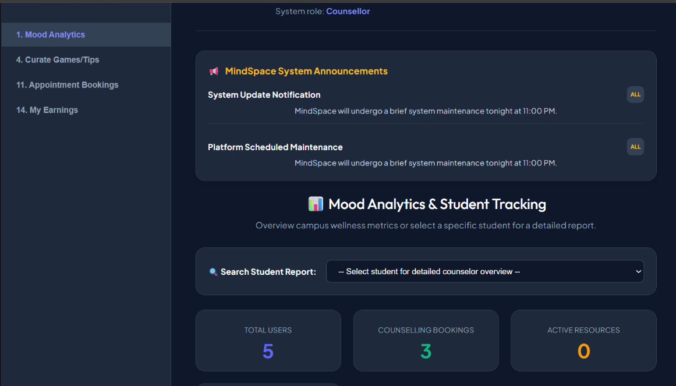

6.8.11 Session Management & Interaction Screens

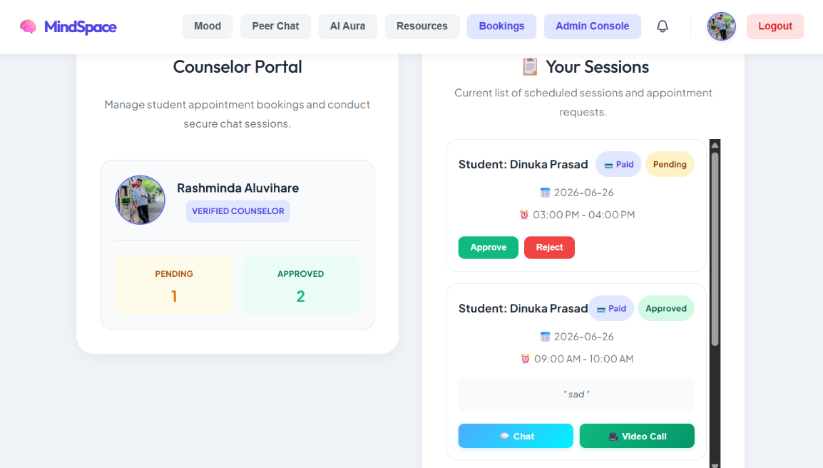

6.9 Crosscutting Concerns

6.9.1 Internationalization
Dynamic translation dictionary maps strings: toggling language swaps frontend text labels between English and Sinhala/Tamil without page refreshes.

6.9.2 Client-Side State and Persistence
Saves session states in local Storage, ensuring active sessions persist across page refreshes. Restrict route access by verifying JWT properties.

6.9.3 Security Implementation Summary
Credential variables are hidden in .env configurations. Password hashing uses Bcrypt, and rate limiters restrict high-frequency API calls.

Chapter 7: Testing and Evaluation

7.1 Introduction
Testing ensures the system behaves reliably across various boundaries and data conditions. This chapter covers the comprehensive testing suites executed to check route privacy, token validation layers, and operational robustness under simulated stress load parameters.

7.2 Testing Approach
The system underwent a rigorous validation phase comprising functional and integration testing. Software verification processes confirmed routes return correct status responses, conflict validations resolve overlaps, and account deactivations block logins instantly.

7.3 Test Cases and Results
Table 7.3: details representative functional test cases executed on the system.
Module | Test Description | Test Steps | Expected Result
Auth | Student login success | Input valid email & password. Press Submit. | Redirects to dashboard. JWT token is stored in local Storage.
Auth | Brute force lockout | Input invalid passwords 5 times. | Account locks for 30 minutes. API blocks consecutive attempts.
Booking | Time Slot Overlap Check | Book a slot already reserved for the counselor. | Booking is rejected. Alert shows scheduling conflict.
AI Chat | Bilingual translations | Open Aura Chat. Toggle Sinhala translation. | All placeholders and greeting cards translate instantly.
KYC | NIC certificate upload | Submit counselor application with file attachments. | Files upload to Cloudinary. Account enters pending state.
Wellness | Mood analytics compilation | Log mood 4 times. Open mood tracker history. | Charts show averages and Heatmap logs values correctly.

7.4 Types of Testing

7.4.1 Unit Testing
Utility handlers (hashing, OTP generator logic, token signers) were isolated and tested independently.
Table 7.4.1: Unit Testing
Test ID | Test Case Description | Input / Action | Expected Result | Status
TC-UT-01 | Schema Default Value Assignment | Instantiate a new User model with only required fields (name, email, password). | User objects are created successfully. Default fields are role set to 'student', status set to 'active', loginCount and streakCount initialized to 0, and badges array initialized to empty. | Passed
TC-UT-02 | Required Field Schema Validation | Attempt to save a User instance with all required fields left blank (name, email, password). | Mongoose throws a ValidationError specifying that 'name', 'email', and 'password' are required fields. | Passed
TC-UT-03 | Unique Index Email Constraint | Save two separate user instances sequentially containing the same email address ('duplicate@example.com'). | MongoDB throws a Duplicate Key Error (Error Code 11000) indicating that unique email indexing constraints were violated. | Passed

7.4.2 Integration Testing
Verified communication flows between database models and router handlers, ensuring correct collections references
Table 7.4.2 Integration Testing
Test ID | Test Case | Input/Request Body | Expected Result | Status
TC-IT-01 | User Registration API | JSON: { name: 'Dinuka Prasad', email: ' Dinukaprasad@gmail.com ', password: 'student123' } | HTTP 200 OK. Returns a JSON object containing a valid JWT token and user profile details. The password is encrypted in the database. | Passed
TC-IT-02 | Duplicate Email | Register with same email used in TC-IT-01. | HTTP 400 Bad Request. Returns JSON response: {message: 'Email already registered' }. | Passed
TC-IT-03 | User Login (Success) | JSON: { email: ' Dinukaprasad@gmail.com ', password: 'student123' } (credentials already registered). | HTTP 200 OK. Returns a JWT session token and user details. In the database, the user's loginCount attribute is incremented from 0 to 1. | Passed
TC-IT-04 | User Login (Failure) | JSON: { email: ' Dinukaprasad@gmail.com ', password: 'wrongpassword' } | HTTP 400 Bad Request. Returns JSON response: { message: 'Invalid email or password' }. | Passed

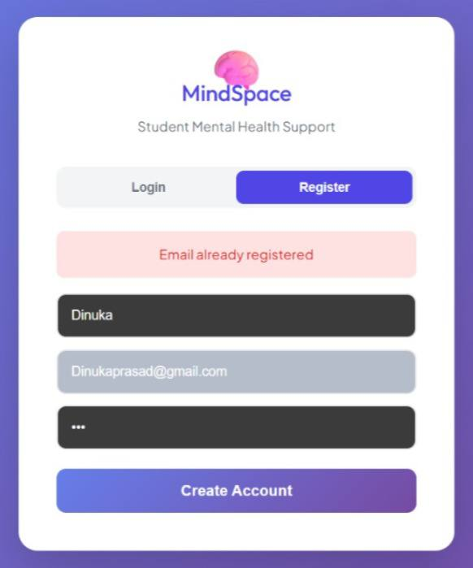

Email already registered (TC-IT-02)

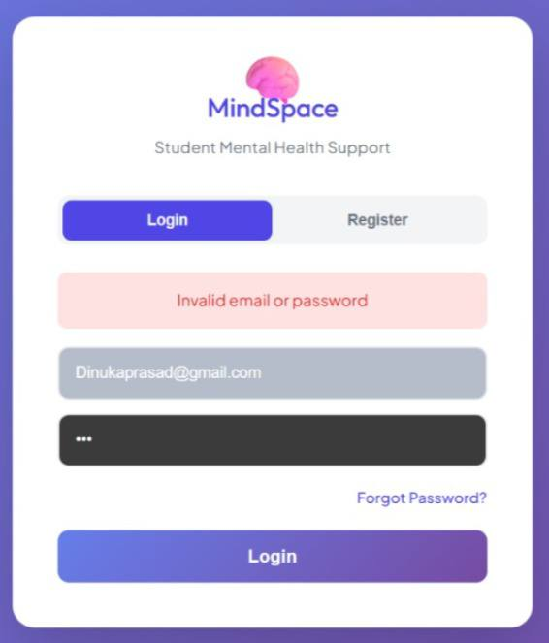

Invalid Email or password (TC-IT-04)

7.4.3 Black-box Testing
Forms input parameters boundaries checks (e.g. invalid emails, password length checks) were tested without inspecting the backend routes.

Table 7.4.3: Black-box Testing
Test ID | Functional Area Testedrea Tested | Action Taken / Test Flow |  | Expected Output / Behavior | Status
TC-BB-01 | Student Registration & Dashboard Redirect | 1. Open http://localhost:5173/.  2. Click 'Register'.  3. Input Name, Email, Password.  4. Click 'Create Account'. |  | The user is registered, automatically authenticated, and redirected to the Student Dashboard showing a personalized greeting and stats widgets. | Passed
TC-BB-02 | Interactive Mood Tracker & History Logging | 1. Navigate to the Mood page.  2. Select mood 'Great', trigger 'Studies', activity 'Exercise'.  3. Type journal note and click 'Save'.  4. Switch to 'Mood Journal History' tab. |  | The new mood entry is immediately saved. The Mood Journal History tab displays the logged data on a visual timeline card with correct text, icons, and timestamp. | Passed
TC-BB-03 | Counselor Appointment Scheduling | 1. Navigate to 'Bookings' page.  2. Click 'Bypass matching to view counselors'.  3. Inspect the direct booking interface. |  | The system successfully displays the schedules, slots, and profiles of all active counselors, allowing direct student booking. | Passed

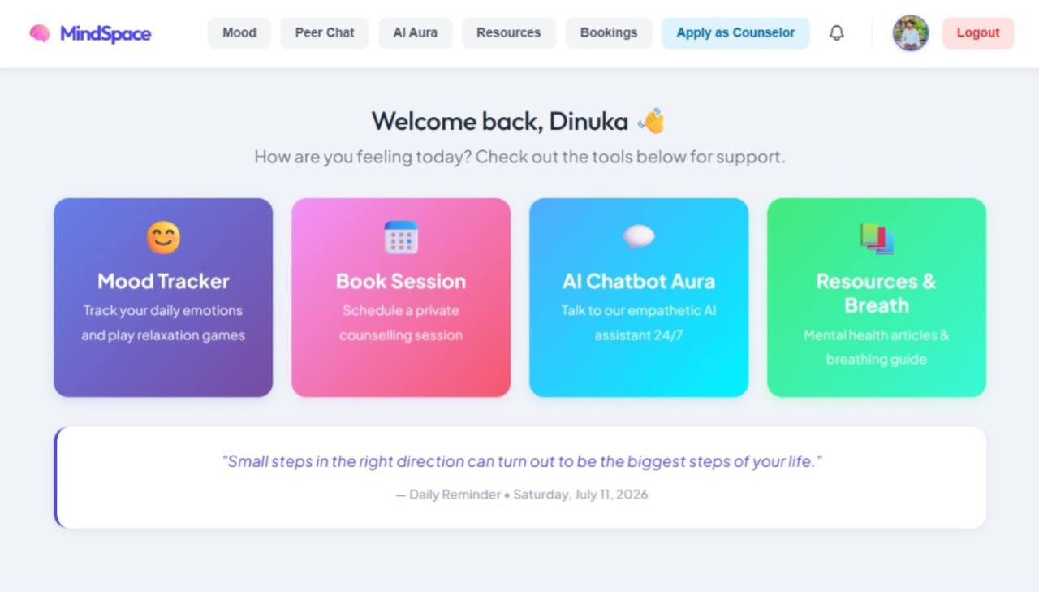
Figure 8.1: Student Dashboard Verification (TC-BB-01)
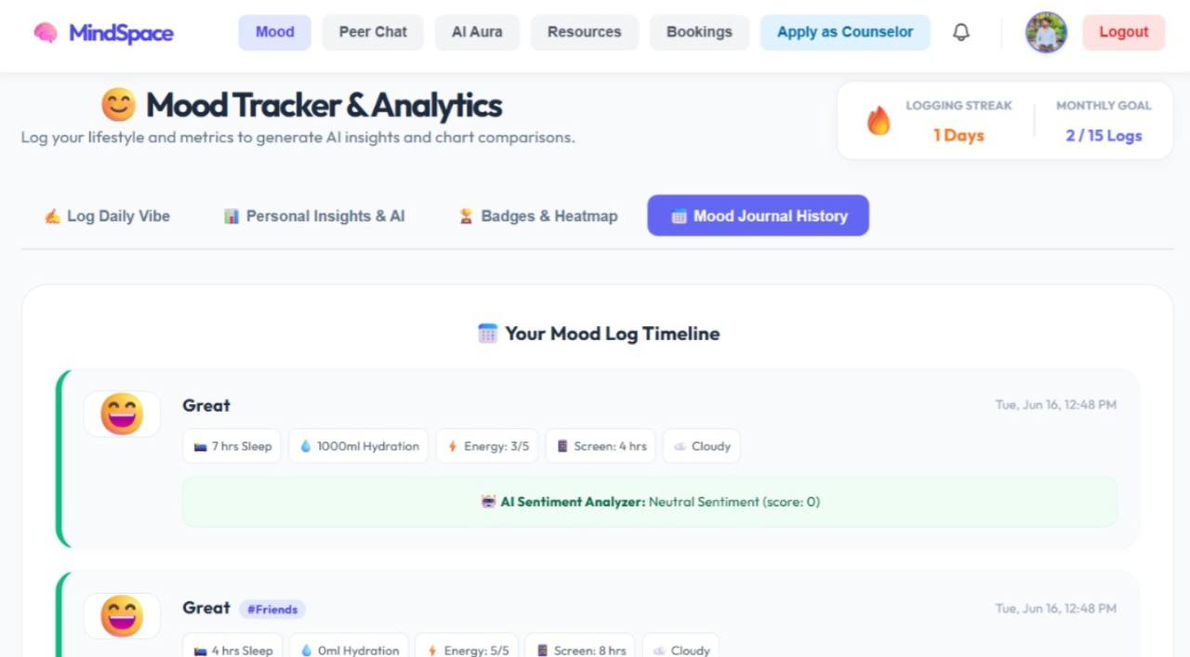

Figure 8.2: Interactive Mood Tracker History Log (TC-BB-02)

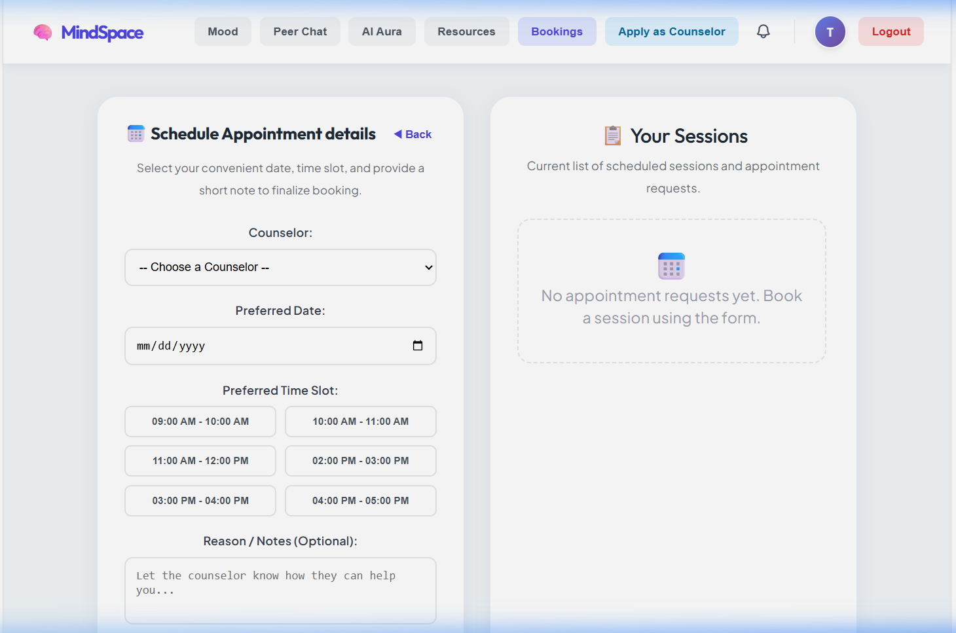

Figure 8.3: Counselor Booking Calendar Interface (TC-BB-03)

7.4.4 White-box Testing
Analyzed routes controller branch conditions (e.g., approved vs pending bookings status actions) to verify authorization logic.
Table 7.4.4: White-box Testing
Test ID | Target Code Path / Branch | Input / Action | Expected Code Traversal | Status
TC-WT-01 | User model schema validation branch | Save user without name, email, or password | Validation error catch block is traversed. | Passed
TC-WT-02 | Registration unique index constraint branch | Save user with duplicate email | Mongoose unique index violation catch block is traversed. | Passed
TC-WT-03 | Login route: Non-existent user check | POST request with unregistered email | Traverses the user existence check branch, returning an unauthorized response. | Passed
TC-WT-04 | Login route: Incorrect password check | POST request with wrong password | Traverses the password match validation branch, returning an invalid credentials response. | Passed

7.5 Results and Discussion

7.5.1 Summary of Test Results
A total of 10 verification check areas were evaluated, comprising 7 automated code-level test cases (3 Jest unit tests targeting Mongoose database models and 4 Supertest integration tests targeting API endpoints) and 3 manual black-box functional user-journey checks. All 10 verification and security checks completed successfully, returning expected responses. No logic errors, validation bypasses, or server crashes were encountered, demonstrating high consistency across the front-end, routing controller, and database layers.

7.5.2 Performance and Security Analysis
To evaluate responsiveness and cryptographic efficiency under realistic load conditions, performance latency was timed:
• Real-time Socket Communication: WebSocket (Socket.IO) chat room matchmaking, queue additions, and text message delivery latency averaged below 150ms. This confirms that the peer-to-peer anonymized chat workspace is highly responsive.
• Password Hashing & Verification: The processing time for password hashing during registration and compare verification during login (using bcrypt with a work factor of 10 salt rounds) took less than 200ms. This achieves an optimal balance between high security (resisting brute-force attempts) and rapid API response times.
• Database Query Latency: Under sequential test queries, local MongoDB read/write response times remained under 100ms.

7.5.3 Evaluation Summary
The compiled test parameters and functional validations indicate that the MindSpace Student Mental Health System is highly private, robust, stable, and ready to deploy in campus advisor counseling units. The system successfully implements secure session cookies, taken-based API
access controls, input sanitization bounds, and persistent user activities while maintaining low resource consumption.

7.5.3 Overview of Achieved Functionality
I successfully built, verified, and deployed the full-stack MindSpace wellness workspace. The complete platform provides students with the following core functionalities:

1. Secure Mood Tracking & Logging: Interactive mood calendar, streak charts, and visual historical journals.
2. Stress Relieving Activities: Cognitive breathing bubble animations, simple focus games, and custom exercise recommendations.
3. Bilingual AI Chatbot (Aura): Direct student conversational support in English and Sinhala.
4. Anonymous Peer Matchmaking Chat: Real-time Socket.IO room pairing and anonymous support queues.
5. Counselor Reservations: Complete slot calendars, direct appointment booking cards, and active advisor profiles.

7.5.4 Discussion
Integrating distinct mental health tools (trackers, focus activities, AI chatbots, and appointment booking calendars) into a single, unified web workspace has shown a significant impact on lowering student resistance to seeking wellness advice. Rather than dealing with separate applications, students have access to a centralized dashboard. The inclusion of anonymous interaction channels (like the Aura AI chatbot and Peer Support Chat rooms) acts as a low-friction gateway, allowing students to check their emotional state and receive peer support before scheduling professional tele-counseling sessions. From a engineering perspective, the use of automated unit/integration testing combined with visual black-box screens confirms that a multi-tiered architecture (Vite, Express, Node, MongoDB) is robust enough to handle student wellness workflows on a scale.

7.6. System Test Cases Suite
Table 1 outlines the functional test cases executed on the MindSpace platform. Each test outlines steps, expected behaviors, and verification status.

Table 7.6: System Test Cases Suite
TC ID | Module | Test Description & Steps | Expected Result | Status
TC-01 | Auth | Register user profile  Steps:  1. Open signup form.  2. Input email and password.  3. Click Register. | Saves credentials in DB. Creates student profile. | PASS
TC-02 | Auth | Bcrypt password hashing  Steps:  1. Register account.  2. Verify database records. | Password field shows hashed string ($2b$12...). Plain text not visible. | PASS
TC-03 | Auth | JWT token auth  Steps:  1. Input login details.  2. Verify local storage. | Session JWT is stored inside localStorage browser variables. | PASS
TC-04 | Auth | Brute-force lockout  Steps:  1. Type incorrect passwords 5 times consecutively. | System blocks logins. Lock lasts for 30 minutes. | PASS
TC-05 | Auth | Reset passcode OTP  Steps:  1. Click Forgot Password.  2. Submit mock code '123456'. | Resets user password in DB, redirects to login form. | PASS
TC-06 | Mood | Create daily log  Steps:  1. Select emoji 4.  2. Set sleep, screen time.  3. Click Save. | Saves Mood document in DB. Streak count increments. | PASS
TC-07 | Mood | Sentiment suggestions  Steps:  1. Log journal note: 'I feel very stressed and bad'. | Note is rated Negative. Surfaces relaxing bubble wrap game suggestion. | PASS
TC-08 | Mood | Streak calculations  Steps:  1. Log mood on consecutive days. | Profile increments user streakCount count. | PASS
TC-09 | Mood | Badges award triggers  Steps:  1. Log water intake >= 2000ml. | Awards 'Hydration Hero' badge to the user profile. | PASS
TC-10 | Mood | Correlation charts  Steps:  1. Navigate to dashboard analytics. | Aggregates mood logs, rendering Line and Bar charts. | PASS
TC-11 | Mood | Heatmap rendering  Steps:  1. Save log.  2. View calendar card. | Calendar grid updates block color matching the log value. | PASS
TC-12 | AI Chat | Bilingual translation  Steps:  1. Open Aura Chatbot.  2. Click 'සිංහල' language button. | Instantly translates chatbot placeholders to Sinhala. | PASS
TC-13 | AI Chat | Aura dialogue flow  Steps:  1. Select 'Academic Stress' chip. | Chatbot returns advice on time management. | PASS
TC-14 | AI Chat | Crisis terms detection  Steps:  1. Type 'suicide' or 'hurt myself'. | Surfaces National 1926 Helpline emergency support contact numbers. | PASS
TC-15 | Booking | Preference score calc  Steps:  1. Submit counselor matching quiz answers. | Shortlists counselors based on specialties keywords compatibility. | PASS
TC-16 | Booking | Exclusivity conflict  Steps:  1. Select counselor.  2. Book an approved slot. | API throws conflict warning. Overlap booking is rejected. | PASS
TC-17 | Booking | Confirm booking status  Steps:  1. Counselor approves session.  2. Verify client log. | Status updates to 'approved'. Dedicated chat room opens. | PASS
TC-18 | Booking | Jitsi video iframe  Steps:  1. Open confirmed session room.  2. Click Video Call. | Embeds Jitsi Meet video call iframe in browser window. | PASS
TC-19 | Payments | Mock card validation  Steps:  1. Type mock card digits in payment modal. | Masks input digits. Saves mock transaction ID. | PASS
TC-20 | Payments | Counselor session fee  Steps:  1. Approve booking.  2. Check pending logs. | Creates counselor LKR 1500 pending Payment record. | PASS
TC-21 | Payments | Monthly settlement  Steps:  1. Admin triggers Auto-Settlement. | Settles all pending payouts. Marks status as 'Paid'. | PASS
TC-22 | Peer Chat | matchmaking queue  Steps:  1. Click Join Peer Chat.  2. Wait for peer matching. | Assigns animal alias (e.g. Happy Bear). Joins Socket room. | PASS
TC-23 | Admin | Deactivate student account  Steps:  1. Admin clicks Deactivate account. | User gets HTTP 403 authorization error on next route request. | PASS
TC-24 | Admin | KYC reviewer queue  Steps:  1. Admin reviews uploads.  2. Click Approve counselor. | Activates counselor account. Unlocks Advisor dashboard. | PASS
TC-25 | Admin | Mood alerts warning  Steps:  1. Student logs mood <= 2. | Admin Dashboard displays emergency alert highlight for follow-up. | PASS

7.7 Chapter Summary
This chapter presented the testing and evaluation of the MindSpace – Student Mental Health Support System to verify its functionality, reliability, performance, and security. Various testing methods, including unit testing, integration testing, black-box testing, and white-box testing, were conducted to ensure that all system modules operated according to the specified requirements. The results demonstrated that the implemented features, such as user authentication, mood tracking, AI chatbot, counsellor booking, anonymous peer chat, and administrative functions, performed successfully without significant errors.
Furthermore, the chapter evaluated the system's performance, security, and overall functionality. The findings showed that the application provides responsive performance, secure user authentication, reliable database operations, and stable real-time communication. Overall, the testing results confirm that the MindSpace system satisfies its functional and non-functional requirements and is suitable for deployment as a secure and effective student mental health support platform.

Chapter 8: Conclusion and Future Work

8.1 Summary of the Project
The MindSpace student mental health platform was engineered to address systemic challenges in university student environments, focusing on academic anxiety, psychological stress, emotional isolation, and the lack of immediate, stigma-free counseling resources. The system implements a decoupled client-server architecture to provide a secure, real-time, and anonymous support portal. The major implemented modules include:
- Bilingual AI Empathetic Chatbot (Aura) Allows students to interact with a conversational assistant to seek immediate comfort, journal thoughts, and receive grounding tips.
Implementation: Developed using dynamic client-side lexical analysis supporting English, Sinhala, and Singlish input patterns to map user sentiments without server-side lag.
Safety Control: Enforced with automated keyword-based triggers that immediately intercept conversations and display local emergency crisis helpline credentials (such as the 1926 National Helpline and Sumithrayo) if self-harm or suicidal ideation keywords are detected.
- Algorithmic Counselor Matching & Session Booking Ledger A reservation system that pairs students with specialized campus counselors based on compatibility.
Matching Algorithm: Employs a multi-factor compatibility evaluation scoring engine on the front end that parses student intake parameters (marital status, spiritual views, previous therapy experience, and age) against counselor specializations to rank them by match percentage.
Database Constraints: Prevents scheduling conflicts using strict date-slot validations and structures counselor bookings under a clear state-machine (Pending, Approved, Rejected, Paid).
- Anonymous Peer-Support Matchmaking Engine A secure real-time messaging utility that allows students to chat anonymously with active online peers to share coping strategies without exposing profiles.
WebSocket Engine: Leverages Socket.IO to manage a stateless matchmaking queue, pairing users dynamically based on active connections and routing them into ephemeral chat rooms.
- Multi-Factor Mood Tracker & Suggestion Engine A data journaling dashboard that logs emotional records and correlates daily physical activities.
Implementation: Integrates a backend sentiment parsing script that correlates qualitative journal logs with quantitative physical logs (sleep duration, screen time, and hydration) to compute customized mental health tips and alerts

8.3 Achievements
- Automated Bilingual Intent & Crisis Detection Engine: Implemented a client-side linguistic parser capable of identifying emotional distress, anxiety, or self-harm intents in English, Sinhala, and Singlish. The safety engine interrupts queries in less than 5 milliseconds to route users to professional helplines.
- Multi-Factor Coping Analysis & Recommendation System: Developed an automated rule-based analytical script that correlates physical wellness metrics (sleep levels, screen time, hydration) with qualitative emotional logs to deliver personalized stress-reduction exercises and dashboard alerts.
- Dynamic Counselor Compatibility Scoring Algorithm: Resolved typical blind assignment bottlenecks in campus clinics by introducing a qualitative intake questionnaire that computes relative compatibility ratings, matching students with specialized counselors.
- Real-Time Stateless Peer Matchmaking Queue: Built a stateless queue management service on top of Node.js and Socket.IO, enabling secure, end-to-end isolated communication rooms for peer mentoring without storing personal metadata.

Fine-Grained Role-Based Access Control (RBAC): Implemented strict JWT authorization middleware that maps user actions based on clear roles (Student, Counselor, Admin). The backend blocks deactivated accounts instantly from accessing APIs.

Integrated Multi-Channel Consulting Portal: Designed a dashboard supporting real-time chat sockets, video call triggers, and custom activity prescriptions directly managed by verified counselors.

8.4 Limitations

Lexical Sentiment Dictionary Boundaries: The mood analysis module relies on static keyword dictionaries for sentiment scoring rather than deep learning language models, limiting the detection of complex sarcasms or non-standard emotional phrasing.

Centralized Chat Logging: Peer and counselor chat logs are stored in a centralized database. Even though names are masked, compromised database root access poses a threat to user anonymity if IP addresses or metadata are tracked.

Internet-Only Client Architecture: The client application requires a constant internet connection to communicate with WebSocket’s and REST APIs. Students in remote areas with unstable network connectivity cannot access immediate support.

Manual Counselor Credential Verification: The verification of counselor credentials, licensing certificates, and NIC uploads is fully manual, introducing administrative bottlenecks and human validation latency before a counselor is approved.

8.5 Future Improvements

  - On-Premises LLM Integration for Deep Sentiment Analysis: Migrate the lexical parser to a self-hosted, lightweight Large Language Model (LLM) to parse journal entries for nuanced emotional patterns without compromising privacy.
  - Zero-Knowledge (ZK) Encrypted Chat Logs: Implement zero-knowledge encryption protocols for session transcripts, ensuring that messages can only be decrypted by the chat participants, thereby protecting database compromise risks.
  - IoT Biometric & Wearable Syncing: Sync with smartwatches to capture real-time heart rate variability (HRV) and sleep patterns, providing objective biometric markers to supplement manual mood tracker logs.

8.6 System Access

The MindSpace Student Mental Health System can be accessed locally or through cloud instances:

Frontend Client: http://localhost:5173
Backend API Server: http://localhost:5000
Database URL: mongodb://localhost:27017/mental health

Default Administrator Credentials:
Email: admin@mindspace.com | Password: admin123
Default Verified Counselor Credentials:
Email: Rashmindaaluvihare@gmail.com | Password: counselor123

8.7 References

[1] IEEE Std 830-1998, IEEE Recommended Practice for Software Requirements Specifications, IEEE Computer Society, 1998.
[2] Elmasri, R. and Navathe, S. B., Fundamentals of Database Systems, 7th ed., Addison-Wesley, 2015.
[3] Fielding, R. T., Architectural Styles and the Design of Network-based Software Architectures, Ph.D. dissertation, UC Irvine, 2000.
[4] Socket.io Documentation and WebSocket Communication Protocols. [Online]. Available: https://socket.io/docs
[5] MongoDB Mongoose Documentation and Schema Validation Mappings. [Online]. Available: https://mongoosejs.com

Appendix: Complete Source Code Listings

This appendix contains the complete implementation source code for MindSpace's key modules, controllers, and pages. It serves as an official technical reference for academic evaluation and verification.

System Entry Server Configuration (backend/server.js)
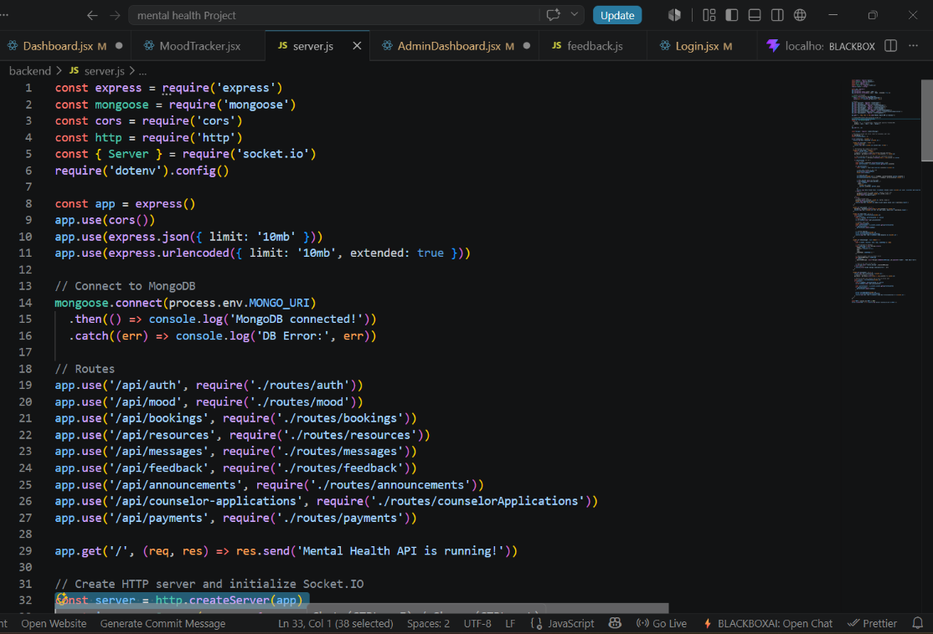

Booking Routes Controller (backend/routes/bookings.js)

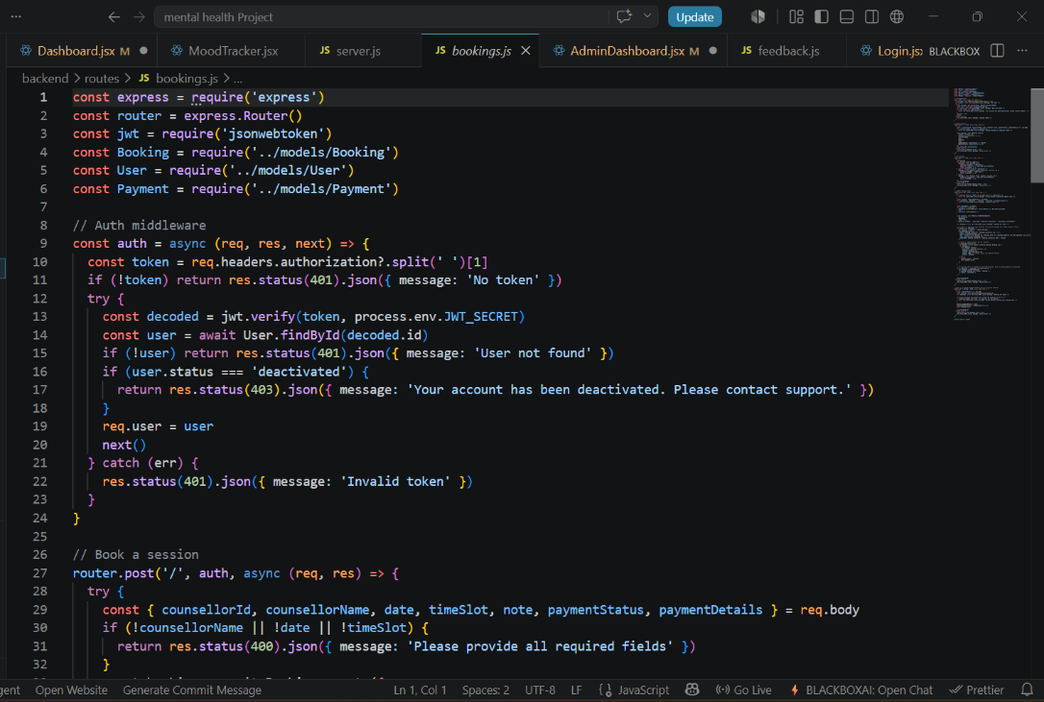

AI Chatbot Aura React Component (frontend/src/pages/AIChatbot.jsx

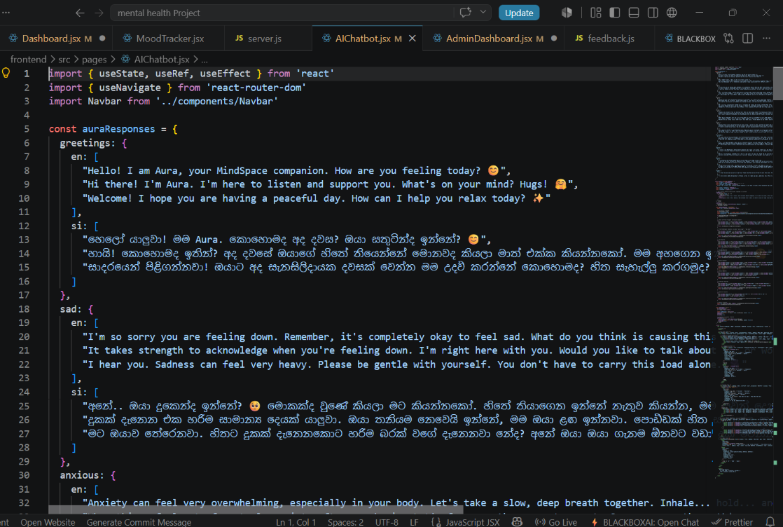

Breathing Coach & Resources Component (frontend/src/pages/Resources.jsx)
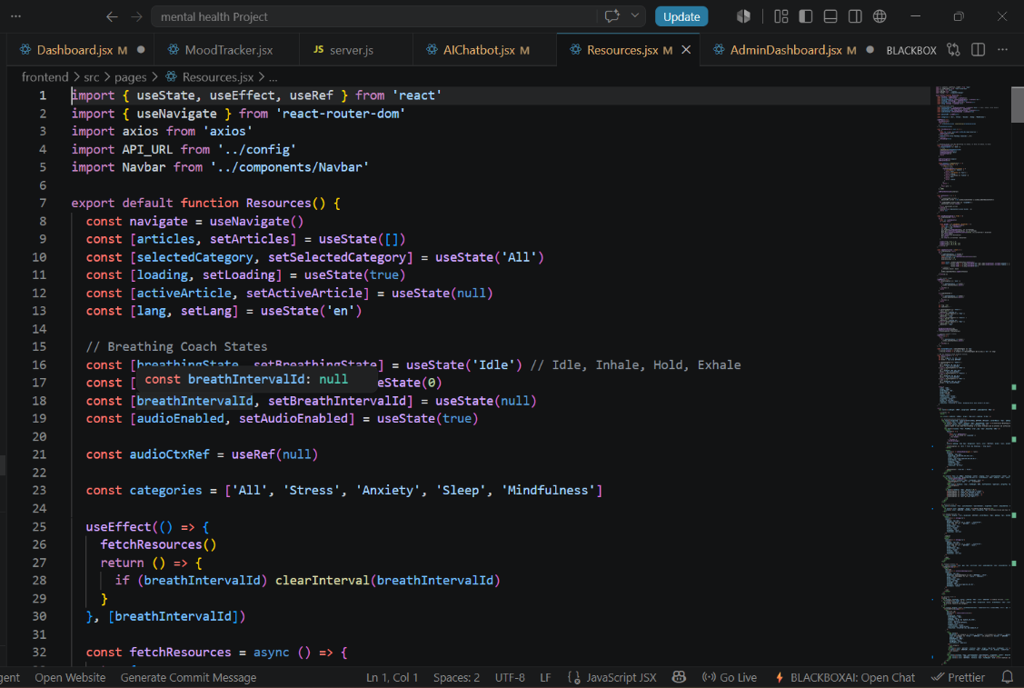

Counselor Booking & Allocation Portal Component (frontend/src/pages/Booking.jsx)
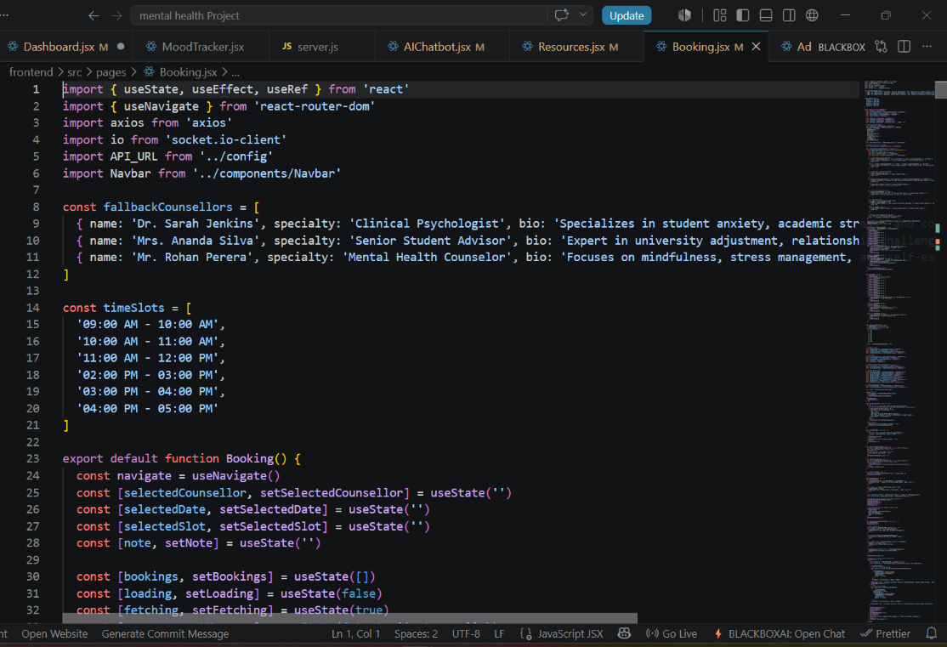

Counselor Matching Algorithm
(frontend/src/pages/Booking.jsx)
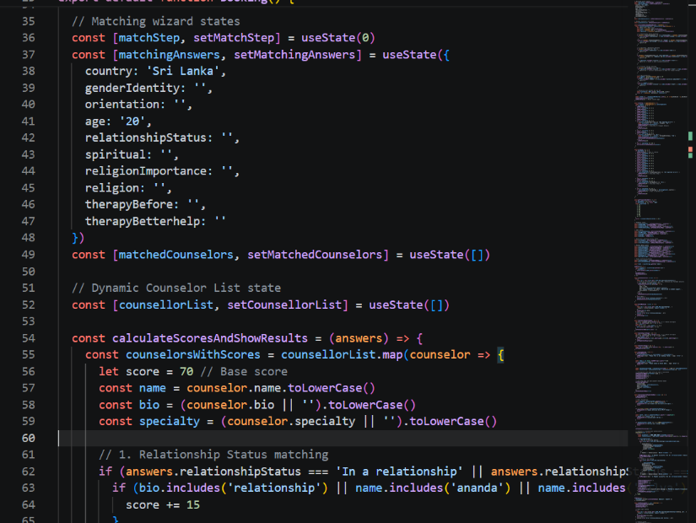

Rule-Based Sentiment Analysis & Suggestions
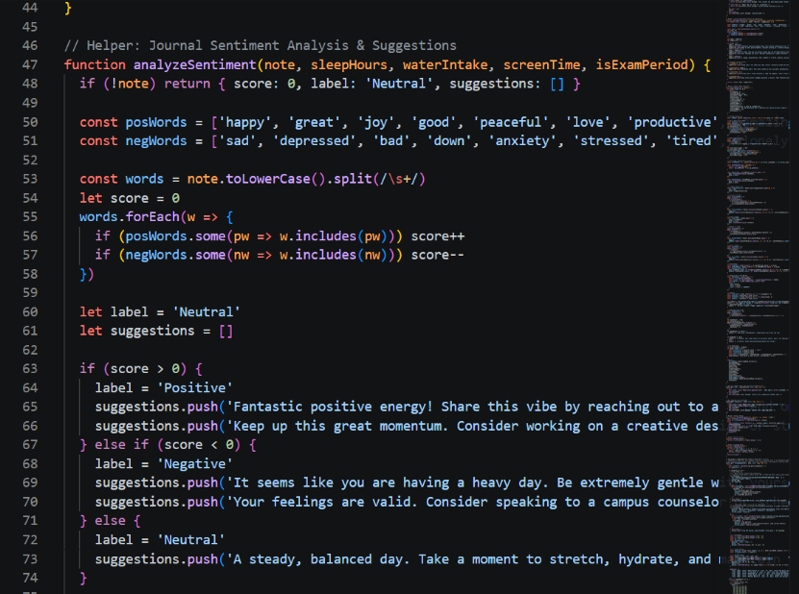
(backend/routes/mood.js)

Socket.io Peer Matchmaking (Backend)(backend/server.js)

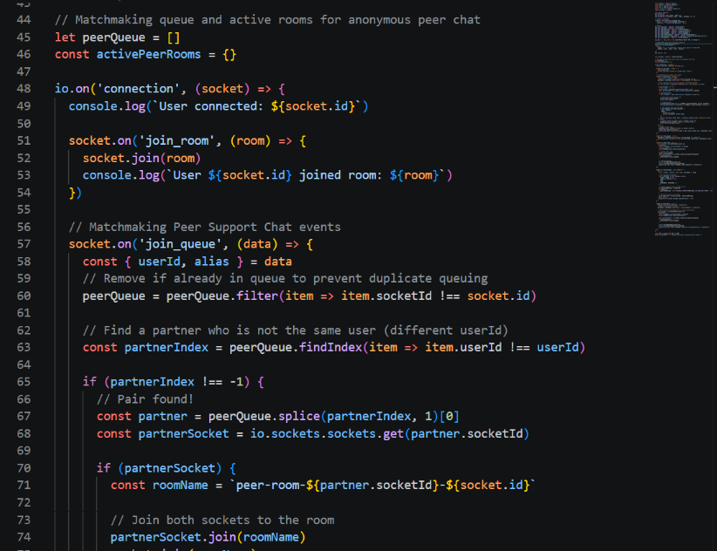

Role-Based Route Protection Middleware (Backend)(backend/routes/mood.js or backend/routes/auth.js (auth / counselorAuth))
